Chip to Kapton Bonding Procedure

Jeff Clark
SCIPP
8/9/99
- Make sure that the holder for the tray is indexed, screwed into the Autobonder snugly and the width is set properly.

2) Load the 5 ½ in. floppy disk labeled chip Kapton into the disk drive. On the right hand column Function buttons (auto, manual, semi-auto….) press the Floppy function key. Press play, (next to floppy function button). The little screen will display the file name, press the accept button.

- Place Tray in holder with HDI and jig facing away from you. Make sure that all four corner posts of the tray are touching and balanced. Screw in 2 thumb or Allen wrench screws into each side of black tray handles.

- Take tray cover off, before pressing index! (This could cause severe damage to the autobonder if cover isn’t taken off)

- Check power on dial indicator. Channel 1= 1.48, Channel 2=1.7

- Press index. Start with chip 0, to the far right of tray.

- Push the semi-auto function key.

- Aligning cross hairs is tricky. The screen will ask for xy1. If it does not, press the restart button.

a) Place cross hairs on the lower right bond pad (white squares) on the chip, along the very bottom and right edges. Press Enter.

b) Display will read OL 1. Leave cross hairs on lower right pad. Press Enter.

c) Display will read OL 2. Place cross hairs on the upper left bond pad on the chip, along the very top and left edges. Press Enter.

d) Display will read DIE 1. Place horizontal cross hair at top of Kapton trace and vertical at very right edge of the Kapton trace. It should be at the edge of the shadow and the gold, but not actually over the gold. If placement is too far to the right, the bonds will miss the mark. Press Enter.

e) Check that you are in Semi-auto mode.

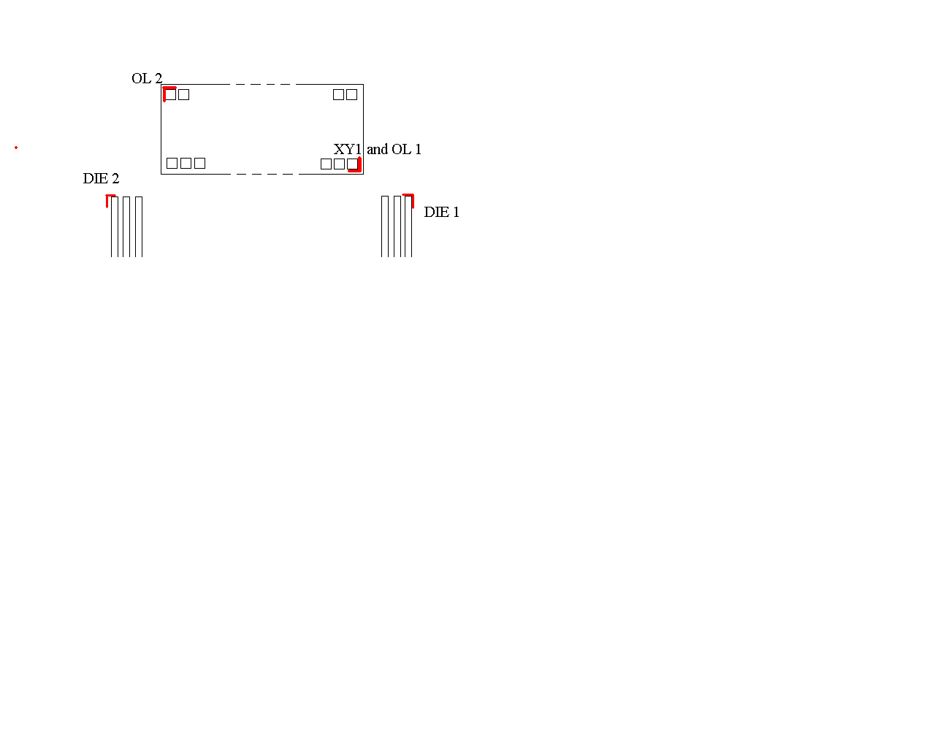
f) Display reads DIE 2. Align in Y (direction parallel to traces) but not in X and press Enter. If at any time the bonder moves to DIE 1, just re-enter the placement until the bonder accepts the value. When in doubt, press Reset and start over.

- Now you are ready to bond. Check that the cross hairs are left of center on the first Kapton trace. Placement of the cross hairs is imperative for good bonding placement for the entire chip. Setting good placement takes practice and should improve with subsequent chips. If alignment is incorrect press Reset and go through section 8 again adjusting cross hairs as needed. If alignment you have just completed is good press Enter. Check placement on chip pad. If it is centered press Enter.

- If bond looks good go into Auto mode by pressing the Auto function button. Watch through the microscope. If at any time the bonds start to run off the pads or stray from proper alignment press Sequence Stop and either align the bonds by hand using Semi-Auto mode or start over again by pressing Reset and use the Skip Wire button in Semi-Auto mode.

- When bonding is finished, press Reset and go to the next chip to the left.

12) Record the chip number and number of failed bonds on chip or Kapton in logbook

13) At chip 19 the tray needs to be moved to the right. Do Kapton to hybrid bonds before moving (see next section). Press Index and loosen the hex bolts using the flat wrench and slide the tray all the way over to the right.
Tighten up bolts, re-index the tray and finish bonding.

14) Press Index and remove tray. Cover tray and give to HDI testers.

15) Fill in the checklist for tray and record name and date.

HDI to Kapton Bonds
The ends of the Kapton and between every 5th chip there are ground and bias voltage traces that need 2 bonds each. Ground traces are skinny while bias voltage traces are thicker and have a two step ending.

Before bonding:
To use the proper parameters, the bonding machine must be in bonding mode. Go through the steps of aligning using the chip to Kapton bonding program outlined above, be in Semi-Auto mode. When the bonder is ready push Sequence stop. Now you can bond anywhere by pressing Enter for point 1 and Enter again at point 2.

Bias voltage trace bonding:
- At the ends of the Kapton, go to a spot on bias voltage trace. Press Enter.
- Go to the L shaped pad with a hole in the one end at the outer edge of the HDI. Find a good spot and press Enter.
- For bias traces in between chips, there are chip to chip bonds in the way. Reverse bond the trace by going from HDI to the Kapton, so as not to hit the chip to chip bonds. Place the cross hairs at the half circle ling trace with a hole in it and press Enter. If there is horizontal distance between HDI and Kapton traces make sure there is room for the bond foot on the HDI trace.
- Set cross hairs on the Kapton bias trace. Press Enter.

Note: There is no bias trace between chips 19 and 20, only 2 ground traces.

Ground trace bonding:
- Locate ground traces and press Enter and move the cross hairs to the wide grounding strip below the chips and press Enter.
- Repeat step 2

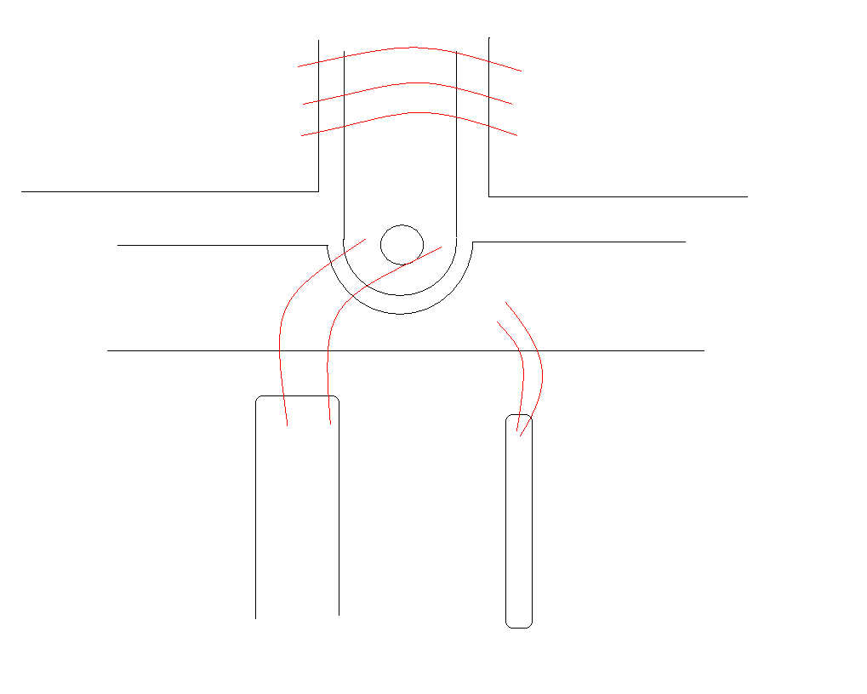

Chip to chip bonds

HDI Bias Trace

Bias Kapton Trace

Changing controller chip address bonds
HDI Ground
Bias Ground
Trace

- Check the old designated address for the chip in tray folder and see if it matches new designation.
- If different, find the address bonds on the left and right chips (see diagram)
- Change parameters of bonder. Press RVL button and change to RVL=200. Next press RVH button and change RVH= 200 (both on left side of keypad). Change the power to 1.7 on channel 1. Press Time button and change value BTM=60.
- Pull the necessary bonds and re-bond according to the diagrams on the following page.
- Push Sequence Stop and press Enter at first bond point and Enter at second bond point.
- Make sure that the bond stuck.

