Muon Lifetime Lab Experiment Description, Data Collection, & Test Results
By Eric Chu & Joe St. Marie
Santa Cruz Institute for Particle Physics
July, 2004
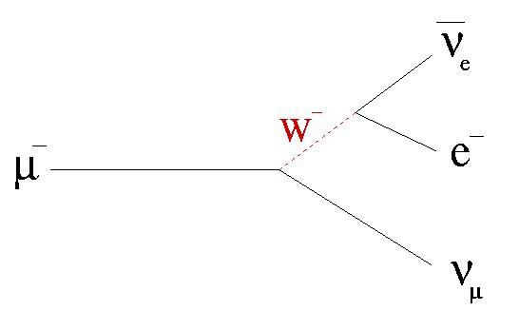
Image from http://www.hep.yorku.ca/menary/talks/seminars/antimatter/muon_decay.jpg
Structure and Use of the Scintillators
A scintillator is a tool used in particle physics for detecting particles. Its construction consists of a rectangular piece of crystal, a light guide, and a photomultiplier tube. The whole scintillator is wrapped to be light-tight, because the whole system works on the basis of light photons generated by charged particles which pass through the crystal.

The way that the scintillator actually works is quite simple for the detection of amazingly tiny particles. When a charged particle, such as an electron or a muon passes through the crystal, a light photon is generated inside the crystal. The crystal has a very strong index of refraction, so the light photon is reflected off the walls inside the scintillator and down the light guide. The light guide serves the purpose of redirecting the photons from the scintillator into the photo-multiplier-tube, or PMT. Inside the PMT, the tiny signal generated by the charged particle is amplified in an avalanche-like system. The light photon causes an electric discharge inside the PMT, and as this charge passes through the PMT, the number of electrons associated with the discharge multiplies. The PMT then sends an output signal to the discriminator and logic. See Figure 1.1 for details.

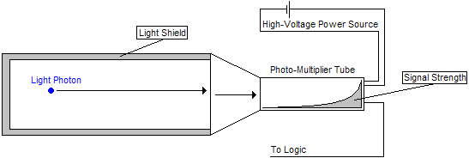
Figure 1.1

For the actual muon experiment, four scintillators are used for particle detection. See Figure 1.2 for details. Because most of the muons which are detected in this experiment come from above the location of the setup, the scintillator on top of the “box”, scintillator A, is used as the trigger. Scintillator A generates the initial pulse, starting the time to amplitude converter—or TAC—which measures the lifetime of the muon particle. The other three scintillators on the sides and the bottom of the “box”, scintillators B, C, and D, are used to stop the TAC as they detect the electron which is emitted in the muon decay. Of course, there is always the issue of a muon flying straight through the setup and sending a signal through the starting scintillator and a stopping scintillator at the same time, but that type of noise is vetoed in the logic. There is also the problem of electronic noise, or unwanted signals coming out of scintillators, but the discriminator thresholds are set to reduce this as much as possible.

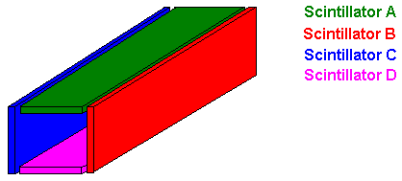
Figure 1.2

Purpose and Wiring of the Discriminator, Logic, and TAC
A description of the scintillator setup can be found in Figure 1.2. An explanation of the logic unit, the discriminator, or the TAC, can be found in Figure 1.3.

The first step in shaping the data from the scintillators into information with which we can make sense is to filter out some of the noise generated by the scintillators. Each signal sent out by the scintillators has a different strength. If the signal is a real muon decay, the signal will be much stronger than background noise. The discriminator deals with sorting out the weak signals from the strong signals. The discriminator we used had four channels, one for each scintillator. Each channel has its own threshold which we set to an appropriate level to filter out the noise. The threshold is a level of strength that the signal must surpass to be passed on through the discriminator. If the signal is not strong enough to make it through the discriminator, it is disregarded by the system. If the signal is strong enough, the discriminator sends a defined square pulse (which means that the properties of the initial input pulse are disregarded) as an output.

The next step in shaping the data is using the logic properly. The manor in which we wired the logic allows for scintillator A to start the TAC if and only if the signal is not vetoed by a simultaneous signal from scintillators B, C, or D within the time of the pulse width of scintillator A (80 ns). A simultaneous signal would indicate a muon passing through the system without decay, causing one of the other scintillators to fire at approximately the same time as scintillator A. The way this works is that the logic operates with two channels. If the top channel receives a signal, it will want to send out a signal. If the bottom channel receives a signal from any of the three scintillators, it will send out two signals. One of the signals will stop the TAC, the other will silence the top channel from sending out any signal to start the TAC (as shown in Figure 1.3). If there is a proper muon decay detected by the system, the top signal will send out the start signal for the TAC, and the bottom channel will send out the stop signal for the TAC.

The TAC itself is what translates the data from the scintillators into language we can understand. It is a very accurate stopwatch that begins when the muon passes into the domain of our “box” and stops when the electron from the decay leaves our “box”. The TAC converts the time into an electric charge linearly proportional to the amount of time for which the TAC ran. The TAC sends out this signal to a computer which keeps track of each decay reported by our system. The program which was used, Maestro, interpreted the signals from the TAC as energy in the units of eV.

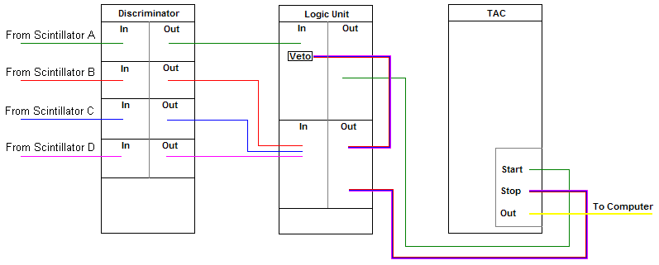 Figure 1.3

Final Information Readout
The final data readout comes from a computer which receives every output from the TAC. The computer sorts out the signals and gives us a readout telling us how many counts were recorded at each energy level. However, we wanted to know how many counts were recorded at each period of elapsed time, so we needed to convert energy to time. Using a gate generator which outputs two pulses with a fixed time difference, we made a graph to convert keV to µs, or energy to time (as shown in Figure 1.4). This graph was generated by setting the gate generator to different times and recording the energy readout at those times. For example, when the time was set to 1.5µs, the energy readout was 155keV. The data is linear and the slope of this graph gives a conversion factor of 103 keV/µs

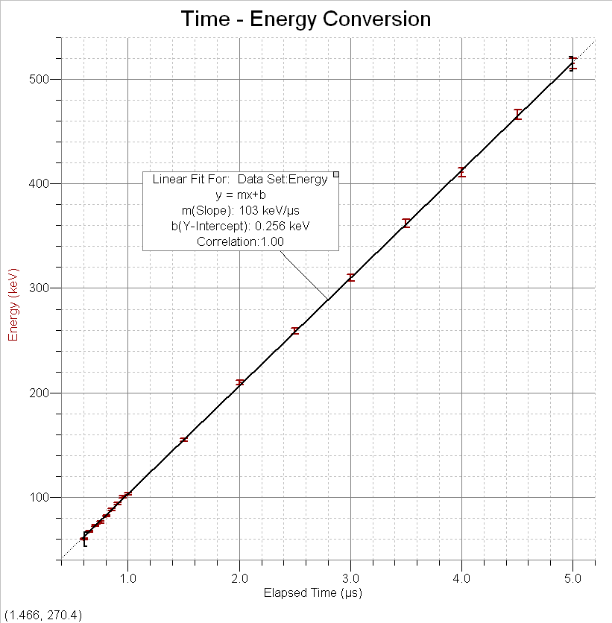Figure 1.4

Changes for the Final Experiment
When we ran our final experiment, we were down by one scintillator, so we had to adjust our setup accordingly. Because we had only three scintillators, we needed to adjust the geometry of the system and we needed to rewire the logic. We decided that a triangle would work for the new scintillator setup. See Figure 1.5. The logic was wired the same way it was for four scintillators, except there were only two clock-ending signals with our new setup. See Figure 1.6.

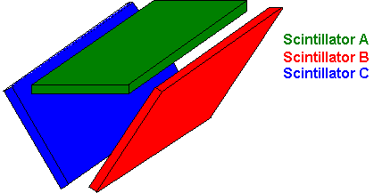
Figure 1.5

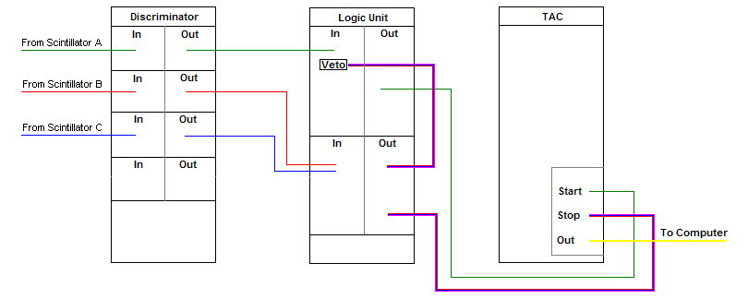 Figure 1.6

Another important change for the final experiment was that the thresholds were actually set. Normally, the easiest (and most conventional) way to set thresholds would be to use a radiation source. However, because of a lack of radiation training, we had to set the thresholds by using a coincidence setup. Each of the graphs that were made from the coincidence setups has the same generic shape. Figure 1.7 shows the graph that was made from scintillators A and B (with A being fixed). The coincidence graphs for the other scintillators and the single count threshold graphs are shown in Appendix A.Coincidence graphs start off with a plateau. Eventually, a drop-off will occur (and it is around this drop-off that one would want to set the threshold). The arrow points to where we decided to set the threshold.
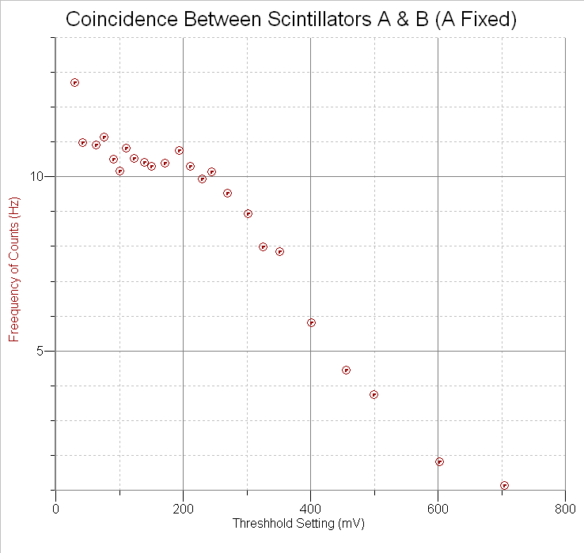Figure 1.7
Threshold set at 200.110 mV

Results
Although we ran a total of four muon lifetime experiments, only two of them have procured data that is worth analyzing (the first experiment and the final experiment). The second and third experiments were both cut short (meaning we had to stop them prematurely) because of various defects that we found in the hardware (one of the scintillators was broken, threshold levels were set too high, not enough voltage was being given to a scintiallator, etc.).

First Experiment
The results from the first experiment actually turned out to be pretty good—it looks like results for a muon lifetime experiment. However, they were also a little off—possibly due to low efficiency and high noise. Figure 2.1 shows the data that was collected.
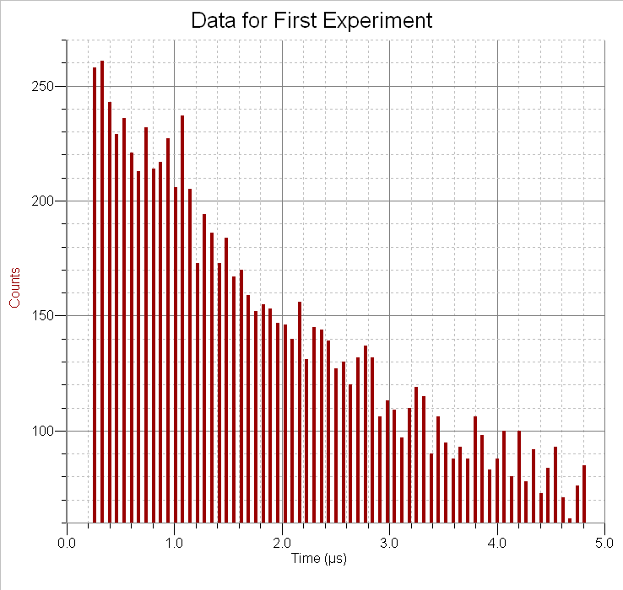Figure 2.1

If a curve fit is done (using the natural exponent equation, f(x)=A*exp(-C*x)+B, and without subtracting the background because B should account for it), the data gives a time of 2.695 µs—with a range, given by the errors of the curve fit, of 2.421 µs to 3.040 µs for the average lifetime of a muon (refer to Figure 2.2 for the graph). The average lifetime of a muon that is listed in the particle data book is µs

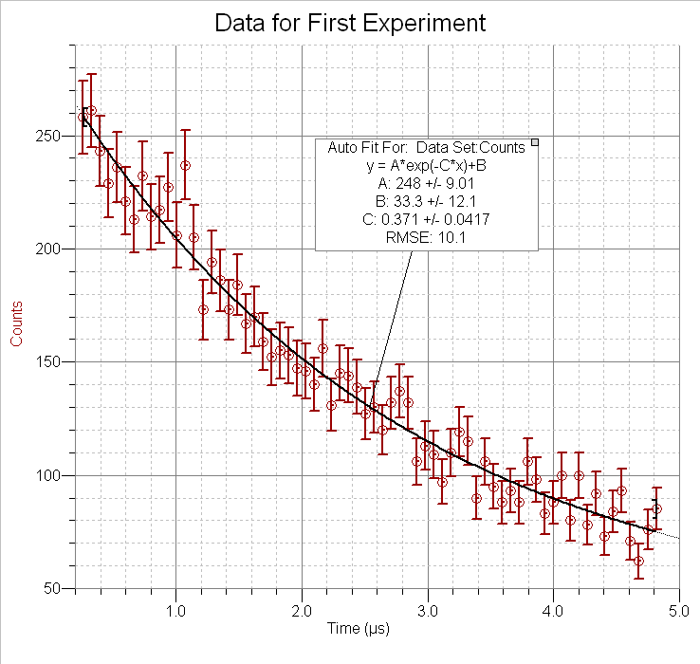Figure 2.2

Experimental Lapses
Some “experimental boo boos” that occurred in our first experiment was that the thresholds were not properly adjusted, scintillator D was broken (the bond between the scintillator and the light guide was practically nonexistent), scintillator C was not receiving enough voltage, and we basically had no veto (an inverse polarity was needed to trigger the veto, therefore, our veto was not triggering). While numerous, these lapses only decrease the efficiency of our experiment. The improper thresholds (they were set too low) would yield more accidental counts. Scintillator D being broken would decrease the number of signals that would be coming from it, thus decreasing the overall number of counts (because D would trigger less often, the TAC would not be stopped as often). Scintillator C not receiving enough voltage would also lower the number of overall counts (because less power going to it means that there are fewer—and weaker—signals coming from it). And, the lack of veto would increase the overall number of counts for the lower energy region (lower time region) because accidentals would be recorded as actual events (instead of being ignored).

Final Experiment
The results from the final experiment did not turn out as expected. Figure 2.3 shows the data for the final experiment. One can see that it is quite different from the results obtained from the first experiment.
We are completely baffled as to why there is a spike in the number of counts in the lower energy (lower time) region. One possible theory is that the ADC (the analog to digital converter) on the computer was malfunctioning and binning the data into wrong bins. We have done tests (using a pulse generator) to see if that is the case and there is evidence that the ADC accidentally bins some of the signals in the wrong bin.
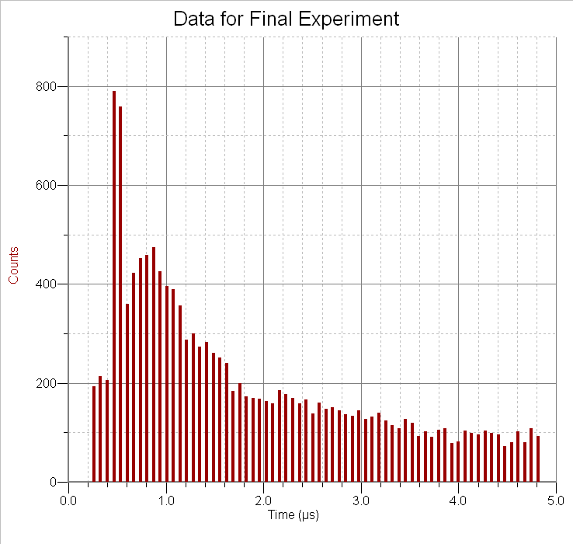Figure 2.3

Much to our surprise, when we tried to fit a curve to the data (using the same equation as before), the value we got for the average lifetime was not that far off (2.024 µs—refer to Figure 2.4 for the graph). However, one reason maybe because the graphing program that we are using (Graphical Analysis 3) is rudimentary. Therefore, it might not take into account the spike in counts (lower time region) and the sudden drop-off in counts (between 1-2 µs).

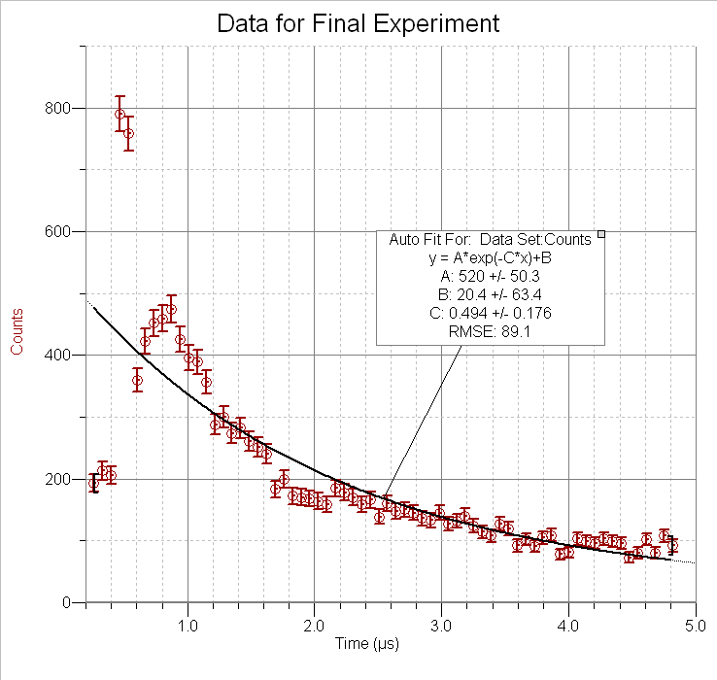Figure 2.4

Experimental Lapses
There were less “boo boos” this time through the experiment. We had fixed the issue of the broken scintillator (by removing it from the setup), the scintillator not receiving enough power (by using a new power supply), and the thresholds (by setting them). However, the one thing that we were unaware of was that the veto needed to be of reverse polarity. Therefore, on this run through of the experiment, we were working without a veto again. Again, it shouldn’t affect the data much (especially now that we set the thresholds so that weaker signals would be ignored), it’s just going to cause a couple of extraneous counts.

Conclusion
The final consensus is that while each experiment was successful in its own way, each also had discrepancies. The first experiment did not have thresholds set and also was using a bunch of less-than-ideal hardware. The second experiment had really weird and unexplainable results. Also, both experiments were ran without a veto. On top of that, the results from the first experiment might be considered “too perfect” (meaning that there aren’t enough errors statistically speaking). The results of the second experiment might be considered garbage if viewed from a statistical point of view too (because too many points lie outside of the curve). However, we consider these experiments successful because we were able to get some results (results that are relatively close to the agreed upon average lifetime). More importantly, we consider these experiments to be successful because of the great deal that we were able to learn just by doing them.
Appendix A

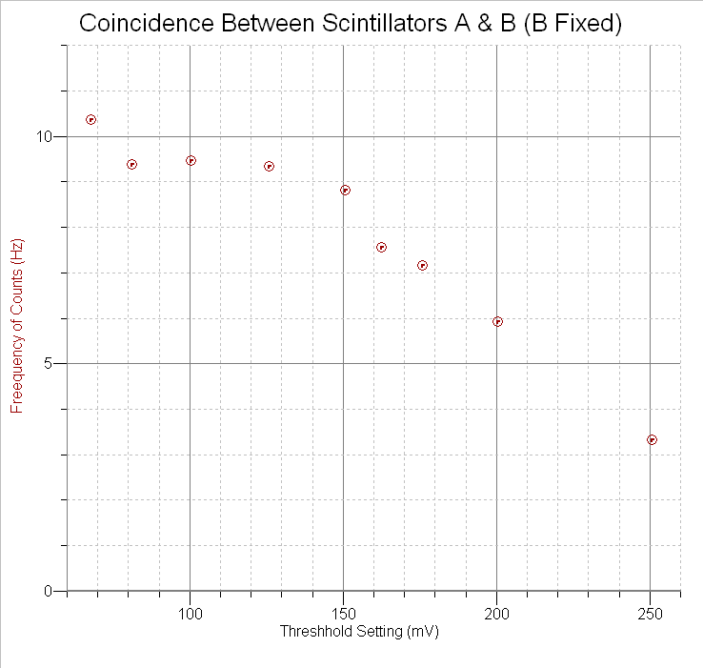
Threshold set at 120.026 mV

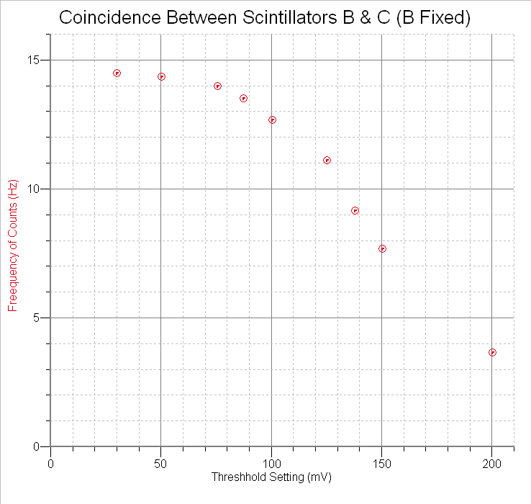
Threshold set at 70.601 mV

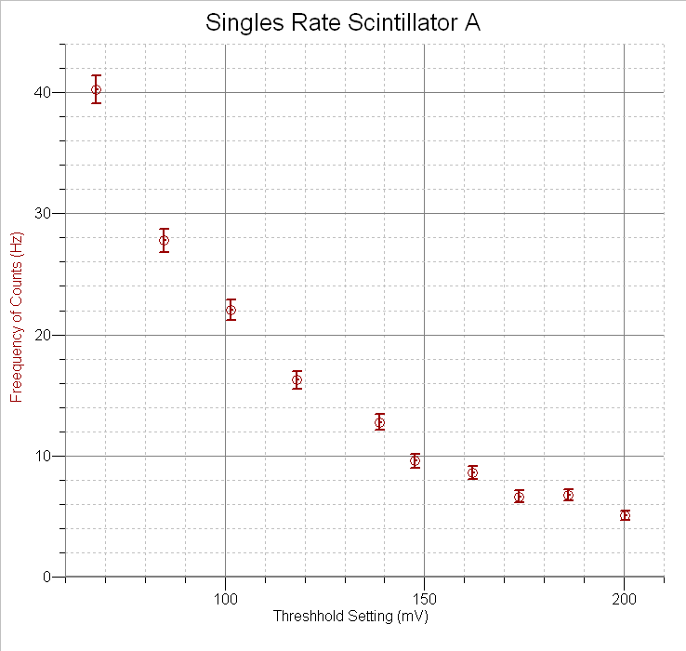

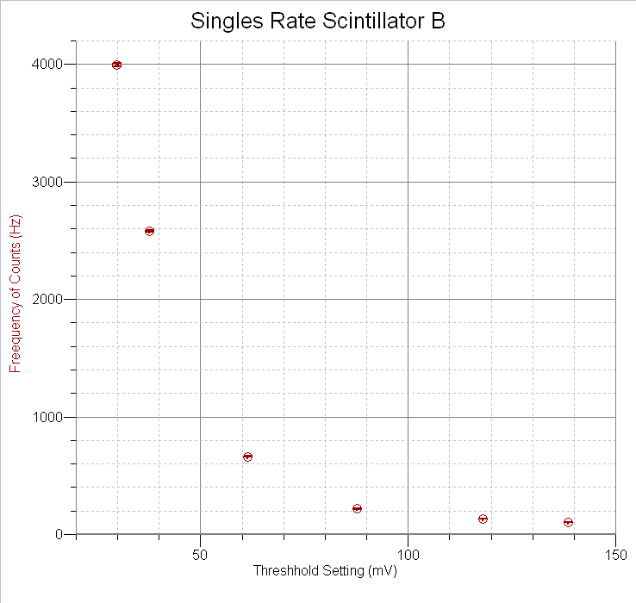
*Error bars are present—the scale is just so big that they are not easily visible

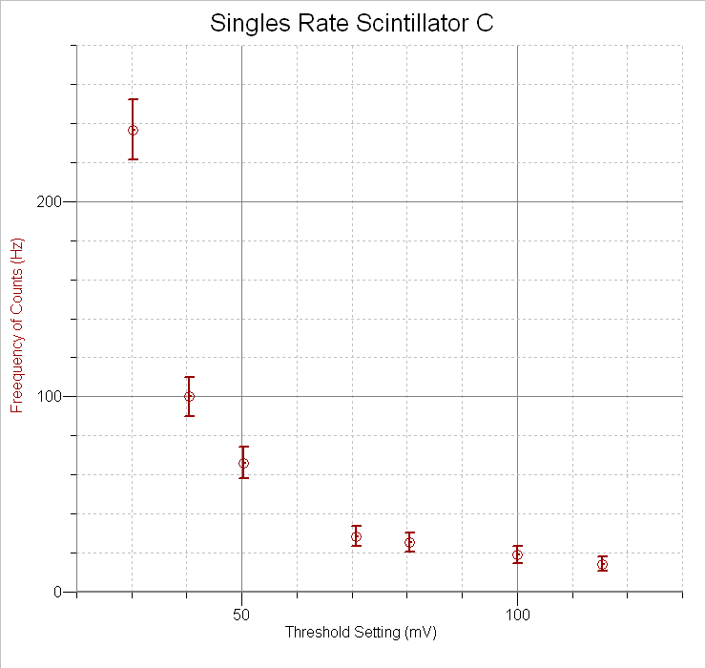
Thanks
This wouldn’t have been possible if it weren’t for some amazing people that we had the privilege of working with. We would like to thank:
- James Dann for reviewing this paper, for being our mentor, for everything else that he’s done, and especially for putting up with us for three weeks!
- Hartmut Sadrozinski for taking the time to lecture us, for helping us when we had problems, and for “grilling” us
- Steve Kliewer for doing a ton of research and for aiding us whenever we needed it
- Stu Briber for explaining things to us, for giving us a tour of the building, and for letting us (as in Joe) ride the recumbent
- Dave Dorfan for helping us analyze the data and for giving us advice in his own unique way
- Terry Schalk for giving us advice and for helping Hartmut grill us
- Marcus for assisting us when we were stuck
- John for helping us whenever we needed it and for teaching us how to polish scintillators
- Jason for helping us out whenever he could
- Scott, Ashlin, and Jo just for being great people to work and be with

