COSMOS/ Ouarknet Summer 2004 Internship Paper: Scintillators

Co-authored by:
Scott Rohlf (June 28th- August 5th) and Ashlin Mountjoy (June 28th - July 23rd)

Note: Specific regions of writing are designated, but both interns revised the whole paper.

Abstract: -Scott Rohlf
During the summer of 2004, two high school students interned with the Santa Cruz Institute for Particle Physics, through the COSMOS/ Professional Training Program, an internship program for COSMOS alumni. During this internship, Scott Rohlf and Ashlin Mountjoy, among other things, attempted to construct working scintillators and test their ability to detect incoming cosmic rays. This is their story.

1. Introduction –Ashlin Mountjoy

Several projects and experiments at the Santa Cruz Institute for Particle Physics at UCSC require cosmic ray detectors. As summer interns at SCIPP, it was our job to build and test these detectors, or scintillators. We built three small scintillators labeled 1-3, and built and/or re-wrapped as series of larger scintillators designated H1, H2, H3, and Dot, and in other experiments a set of four scintillators were used, A-D. For about 5.5 weeks we made multiple attempts to find the perfect procedure for building these panels. As of yet, we have not found it. However, we have made much progress in revising the various steps of the process. This paper serves to explain our methods, failures, and successes of the scintillator saga.

1.1 What is a Scintillator?
A scintillator is a rectangular piece of acrylic that has been coated with luminescent material so it fluoresces, turning the plastic surfaces blue when exposed to sunlight. The scintillator is used to detect microscopic charged particles, which, as they are passing through, excite the electrons of the scintillator material, thus producing a photon. This photon is then reflected inside the scintillator, through a light guide at one end, into a photo multiplier tube (PMT). The PMT turns this photon into an electronic signal, which is sent out by the PMT’s base, which can then be read by various computers and machines. The scintillator, light guide, and PMT must be optically clear, and aligned correctly in order to work properly.
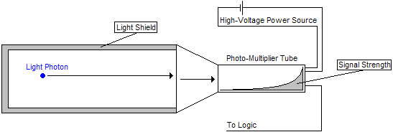

2. Building the Scintillators –Scott Rohlf
2.1 Polishing and Sanding
Polishing and sanding were our first steps in creating the detectors. They are relatively simple, yet tedious tasks. All sides of the scintillators and light guides must be lacking of any scratches or grooves received during the milling or handling. Any imperfections in the plastic interfere with the swift passage of photons and therefore must be polished away. The easiest way to do this is to start with 350-grit sandpaper perpendicular to the grooves of the milling. The perpendicular motion allows one to easily see when the previous scratches have been eliminated and the new scratches occur. Douse the sandpaper with water to contain the shavings and to reduce heat. When the grooves from the milling disappear, and grooves from the sandpaper appear, switch to a 400-grit sandpaper and go perpendicular to the direction of the 350-grit marks. Continue this process and stop after 600-grit
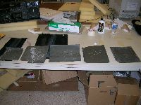
sandpaper. At this stage, we switched to an automotive polish called Meguiar’s Plastx, but a generic plastic polish should do the trick. The polish should be spread out on a piece of felt in a line. Run the scintillator, with some downward force, in one direction over the polish multiple times until the surface appears clear. A perfectly polished piece will not distort an image when it is looked at through the plastic.
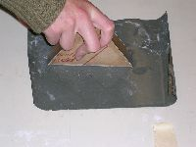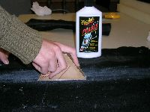

2.3 Gluing
The glue used for the scintillators is also vital. The connection between the scintillator and the light guide must be optically clear. When one looks at a scintillator in the daylight, one can see that it emits light near the blue portion of the visible spectrum. This is also near ultraviolet light on the spectrum. Due to the fact that we cannot see UV light, we cannot tell whether or not the scintillator is detecting cosmic rays and releasing UV photons. We must have glue that does not hinder these photons, but even if the glue appears invisible to us when cured, UV photons cannot necessarily pass through. A good test to see if the connection is clear is to cover the end of the scintillator and the light guide with a heavy black fabric. The middle part of the scintillator should still be exposed to sunlight. If one looks at the end of the light guide where the PMT will be connected, it should be a deep blue showing that most of the photons have made it though the glued connection.
The optical coupling between the scintillator and the light guide is just one concern that needs to be addressed when choosing glue. Many others are strength (we found some optically clear glued that were easy to break), curing time (many types of glue did not cure with hours of waiting), availability (some of the best glues are very hard to find), and cost. There must also be no obstructions within the glue, such as air bubbles. In the process of finding the perfect adhesive, we made multiple attempts with different glues, each of which had its own pros and cons.
First attempt: Norland Optical Adhesive 61- doesn’t cure
Second attempt: Plastix- Optically great, expensive, cures quickly
Third attempt: Surfboard Resin- not optically ideal, air bubbles
Fourth attempt: Duco Plastic Cement- air bubbles

Fifth attempt: Epoxy- did not cure
Sixth attempt: Five minute epoxy- possible air bubbles but easily extracted

After making the above attempts, we settled on the glue Plastix. Plastix is a cyanoacrylate, or super glue, so it cures almost immediately. It cured so quickly at times that we were not able to align the light guide and scintillator correctly. Fortunately, practice makes perfect, almost. This glue came in an expensive .06 fl oz tube. Our first try with a large scintillator yielded 88% efficiency, but our second attempt with a small scintillator about 1/6th the size has given some of the strangest results that students and faculty at UCSC are trying to decipher. This scintillator only had 13% efficiency, which is extremely low. Testing efficiency and reasons why the smaller scintillators didn’t work will be explained later. We eventually switched to a five minute epoxy that has great optical coupling, and has been known by others to work more often than not. And with the five-minute curing time, we were able to align the scintillator and the light guide properly. However, our results are still unwarranted; our second and third scintillators only had 12% efficiency.

2.4 Wrapping
Recall, as a cosmic ray enters the scintillator, and excites an atom in the acrylic, a photon is released. This photon must ‘bounce’ around the scintillator, into the light guide, which, as it’s name states, must guide the photon to the photo-cathode of the PMT that picks up the photon. This must be done with no considerable loss of energy. Ergo, there must be a highly reflective material surrounding the scintillator and light guide all the way up to the PMT, ensuring that no photons can escape. Likewise, we cannot have any light entering the scintillator or light guide from the outside; light tight tape is used for this. To make our scintillators reflective, we wrapped them in either Mylar or aluminum foil (there is no difference between the two). An easy analogy for wrapping the near rectangular scintillator in Mylar/aluminum is to wrap it as one would wrap a birthday present. There should be as few wrinkles as possible and no gaps.
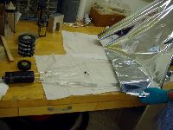
The tape is another issue. To make the scintillators light tight, we used black Scotchrap tape 10mil. From there electrical tape was sufficient to hold down stray parts of the Scotchrap tape. It is best to cover the end of the scintillator in small pieces and then, starting near the end of the scintillator, at a slight angle towards the PMT, wrap the scintillator in one large helical strip. Note: the trapezoidal shape of the light guide creates problems with taping. Be careful and try to make the tape as flush to the scintillator wrapped in Mylar/aluminum as possible. The difficulty of taping the connection of the light guide to the PMT depends on the orientation of the PMT. If the PMT is mounted directly on the end of the light guide, in other words, in a linear fashion to the length of the scintillator, the tape can easily be extended to cover the entire connection. If the PMT is connected perpendicular to the scintillator, the best way is to cut thin, long pieces of tape (electrical or light tight); place them between the light guide and the PMT near where the base would be situated, and wrap diagonally along the connection. Be sure to reduce direct handling of the acrylic to minimize the amount of oil and scratches left on the surface.
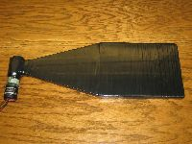
3. Testing the Scintillators –Ashlin Mountjoy

Once the scintillators have been constructed, they must be tested to make sure they work adequately. Then they must be calibrated so that they do not pick up noise (electronic signals picked up by the PMT such as from computers, lights, dishwashers, etc.), yet still pick up a reasonable number of counts. This is done with a variety of machines. An oscilloscope allows one to view the signal as it comes out of the scintillator panel. The width and amplitude of the pulse are just a couple measurable features of an oscilloscope. Feeding the signal into a discriminator will allow one to filter out any low energy unwanted noise. Our discriminators had threshold levels ranging from 30mV and up. Each scintillator panel works most efficiently at different threshold levels so that they filter out as much noise as possible but still detect all real particles. From the discriminator, the electrical pulses can be sent into a logic unit, which will measure coincidences between multiple scintillators. A coincidence occurs when both scintillators detect a pulse at the same time, indicating that a cosmic particle went through both panels nearly simultaneously. When counting coincidences the panels should be stacked on top of each other so they have a chance of both detecting the same particle. Finally there is a counter, which can be wired to record singles counts from individual panels or to count the number of coincidences between panels. Counters are used to calculate the frequency of the pulses. By using the scintillator panels (scintillator, light guide, PMT, and PMT base) and various combinations of these machines, many tests can be done to determine the efficiency of the panels.

3.1 Light Leaks
The first step is to check the scintillators for light leaks, as unwanted light will produce false signals that could skew any results. In order to test for light tightness, the scintillator panel should be connected to an oscilloscope and a voltage source. With the scintillator covered with a piece of black fabric (such as black felt), a dependable signal should be found with the oscilloscope. With someone watching the signal closely, the black cloth can be slowly pulled back, revealing the scintillator to the light. If there is a light leak, the signal displayed on the oscilloscope will increase. Both sides of the panel should be tested this way. If there is no signal increase, then the scintillator is light tight.
However, if the oscilloscope does appear to detect a light leak, a more specific light test should be performed. At this point all lights should be turned off and a signal should once again be found on the oscilloscope. Then a flashlight should be shined slowly across every surface of the scintillator from every possible direction. When the area of the light leak has been identified, a piece of black tape can be placed over the leak, and the area can be re-checked. Once the entire panel has been thoroughly checked, the scintillator is ready for calibration.
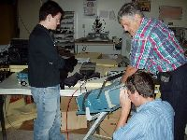

3.2 Efficiency
The next step is to check the efficiency of the counter. To do this two more scintillators are needed. They should be known to be good particle detectors. The scintillator under test should be placed between the others and all three should be connected to a voltage source and a discriminator. The thresholds for all three should be similar, for simplicity. In our tests we used the lowest possible threshold, 30 mV. From the discriminator, the signals should be sent to the logic unit, which will be used to identify any coincidences between the top and bottom scintillators and any coincidences between all three scintillators. Two frequency counters are needed to count these two coincidences.
The efficiency of the scintillator under test is determined by dividing the coincidence count of all three scintillators by that of the two known scintillators (3 coincidence / 2 coincidence). One simple way to do this is to wait for the 2 coincidence to reach a preset number of counts, such as 100, at which point the 3 coincidence counts should be stopped. Then these two numbers can be divided to find the efficiency. The error of this measurement is given by:
Efficiency ± √N N = the number of counts for the 2 coincidence
Any efficiency rate above 90% is considered adequate. Rates far less than 90% result in too many undetected signals. Therefore it is in one’s best interest to make the panels as efficient as possible.

3.3 Singles Rate
Next, the singles count rate of the scintillator should be measured as a function of threshold. In other words, as the threshold is varied, the number of counts in a specific amount of time (for our tests we used 30 seconds) should be recorded. From this data the count rate for each threshold can then be determined. When the data is graphed, results should be close to an exponential decay curve (Ax^-B), with a high count rate at lower thresholds and lower count rates at higher thresholds. At some point the graph will level out and the count rate will remain fixed for all subsequent thresholds, indicating that the threshold is high enough so that little or no noise is picked up. The setup for this test consists of the scintillator’s signal being directed into the discriminator and then into the counter.

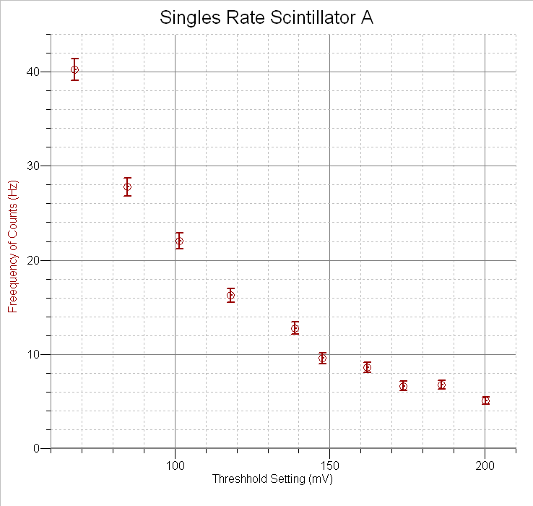

3.4 Coincidence Rate
A third test checks coincidence rates at varying thresholds. The scintillator under test is placed between two other scintillators, like in the efficiency test. All panels should be set at an adequate voltage level and thresholds should be as low as possible. Count the number of coincidences in a particular amount of time (our window was 30 seconds). Dividing this count by the number of seconds will give the frequency of coincidences. Repeat this count for varying thresholds on the scintillator under test.
Note that even if the singles rates for the panels are very high, the coincidence rates will not necessarily be so. The high singles rates are caused by noise and the probability of an accidental coincidence (noise coincidence) is extremely low. The equation for calculating the probability of an accidental is as follows:
P (accidental) = 3τ²N_{a}N_{b}N_{c}
Where N_{a}, N_{b}, and N_{c} are the count rates for the three scintillators and τ (tao) is the pulse width of the signals from the discriminator. For example, in one of our tests, the count rates for the three scintillators were 2700 Hz, 2300 Hz, and 50 Hz. Our pulse width was 150 ns. Even with such high-count rates, the probability of an accidental was only 2.09 × 10⁻⁵.
Coincidence rates, as well as singles counts, are used to determine a working threshold for each scintillator. The coincidence graph should be plateau-shaped, such that low thresholds will have similar coincidence rates until some point at which the rate decreases steadily. The rate plateaus again when all noise has been eliminated.

Coincidence graph of scintillator panel A and H3
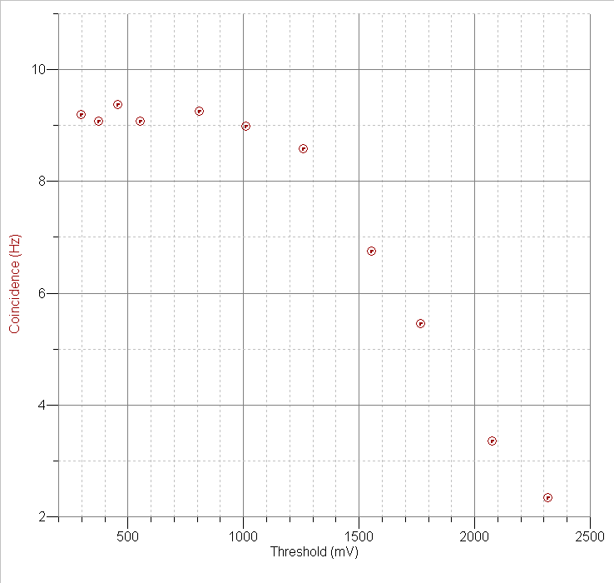

Scintillator A fixed at 1077.5 Volts, H3 variable
When looking at the coincidence graph, the ideal threshold would be the point at which the rate drops. Note, however, that both the singles rates and coincidence rates should be considered. If the leveling out point for the singles counts occurs at a much higher threshold than the dropping off point of the coincidence graph, an average threshold should be chosen. Once all the above steps have been satisfactorily completed, the scintillators should be ready for use.

4. Scintillator Uses –Ashlin Mountjoy

Scintillator panels can be used in several different experiments. The muon lifetime experiment uses four scintillator panels to measure the lifetime of muons.
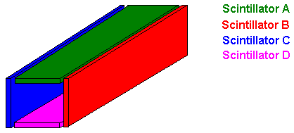

Muons are negatively charged cosmic particles, similar to electrons, yet 200 times larger. They decay into an electron, a neutrino, and an antineutrino:
μ⁻ → e⁻ + ν_{e} +‾ν_{μ}
The experiment is set up with four scintillator panels in a rectangular shape with some dense material in the middle, such as books. The hope is that a muon will come from space through the top scintillator, sending a pulse to the PMT, decay in the books, thus emitting an electron, which will then pass through one of the other three scintillators, sending a second pulse to the PMT. A clock is started when the first signal is received and stopped with the second one. The lifetime of a muon is currently believed to be around 2.19 nanoseconds. (For a more detailed description of this experiment, refer to Joseph St. Marie and Eric Chu’s paper.)
A second use for scintillator panels is the Cosmic Ray Telescope. This telescope is used for detecting charged cosmic particles from outer space. (Refer to Steve Kliewer’s paper for more information on this subject.)
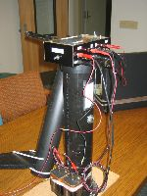

5. Current Situation/Problems –Ashlin Mountjoy and Scott Rohlf

Our final project was to build five small scintillators that would be used in Cosmic Ray Telescopes in outreach programs. The panels had dimensions of 8”×6”×1”. These were to be connected to light guides which tapered on two sides to one square inch. Then a small plastic “cookie” would connect the small cubic end of the light guide to the cylindrical PMT. The first step was to sand and polish the scintillators and light guides to make them optically clear. This led to the first problem: sanding the small ends of the light guides resulted in rounded edges that would not bond perfectly to the cookies. To fix this we milled the small end of the light guides such that the PMT would fit perfectly against them, thereby leaving out the cookie. We then glued the scintillator to the light guide using Plastix super glue. The PMT was connected using optical grease between it and the light guide and then taped into place. The entire panel was wrapped with Mylar and then tape. It seemed to be good. However, we found it to only have 13±10% efficiency when tested with Steve Kliewer’s working scintillator panels.
In our attempts to solve the problem, we made many changes. Our first step was to omit the optical grease with the belief that it prevented a perfect match between the light guide and PMT; there was no difference. Then we tried our PMT with Steve’s panel and his base: our PMT worked. Then we used our PMT with his panel and our base: our base worked. Finally we used our PMT with our panel and our base: it didn’t work. This series of tests allowed us to determine that the problem lay within our panel.
We then made a second panel, tapering the light guide down on four sides so that the small end had the exact dimensions as the photo-cathode in the PMT (8mm x 24 mm). This proved incredibly difficult to cut and resulted in similarly poor results. The second panel had 12% efficiency. With this panel we also used 5-minute epoxy, which Steve Kliewer used in his panels. Next we tried using aluminum foil instead of Mylar, but it made no difference. We had changed every possible element that we could, minus the actual scintillator material. But replacing that far too much time, so we tried another idea.
Our next hypothesis was that our equipment (discriminator, logic, counter) was malfunctioning. The primary problem was that we were receiving adequate singles counts, yet few or no coincidences. We thought that the logic unit was not picking up the signals from the discriminator. However, we checked every input and output step-by-step using a reliable signal source, and everything was working fine, with the exception of one cable, which we replaced. We were back to our original situation in which the problem lay within our scintillator panel.
We know the counts are somewhat real due to the fact that when the scintillators are moved apart the counts diminish.
We wrapped the PMT by itself to see how well the equipment works, and we received many hundreds of counts at high voltages. Ideally we shouldn’t have any counts because if shouldn’t pick up any light. To confuse matters further, when the wrapped PMT was touched we received thousands of counts. We have also realized that Mylar is not completely reflective, though this shouldn’t count for the extreme issues we have been having, plus, our panel with aluminum foil doesn’t work any better.

6. Closing –Scott Rohlf
In our last week, we used an oscilloscope to visibly measure the pulses from the PMT. We found that the pulse emitted from the PMT was usually around 5-15mV. Our threshold on the discriminator at it’s lowest is 30mV. This explains the low counts; hardly anything was large enough to pass the threshold. Unfortunately these lower pulses would be easier to confuse with noise.
To compensate of the lower voltage, we used a x90 pulse amplifier. We left the cathode voltage at 1100V, and the base voltage at 10V, and efficiencies varied from 30%-15%, still not satisfactory, but much better. And as thresholds were raised, the counts dropped steadily, rather than their random changes in amounts. We know that we must be on the right track.
As of the termination of this internship on August 5, 2004, we were not been able to construct accurately working scintillators. We hope that the data we have left will help SCIPP determine what is wrong.

Acknowledgments:
We would like to thank Eric and Joe (other interns) for letting us use some of their diagrams.
Jo Beck for being another awesome intern and comedian.
Stuart Briber and Steve Kliewer for assisting us as much as humanly possible.
Marcus Zeigler, Jessica Metcalfe, Gavin Nesom, and Jason Heiman for lending their knowledge when able.
John Wray for his assistance far beyond what was described in his job description.
Terry Schalk and Hartmut Sadrozinski for their oversight.

