How To Plateau Scintillators
By Melanie Silver and Megan Gritzfeld

Purpose:
Plateauing is a method used to set the optimal voltage and thresholds for the scintillators before completing the muon lifetime experiment. A plateau is where an exponential curve type graph levels out, see figure 1.

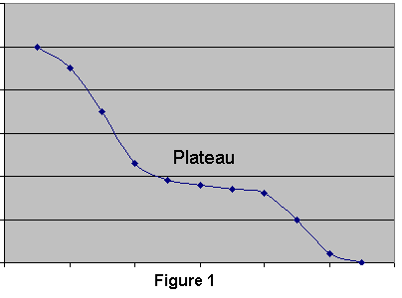
Materials:
- Scintillators (however many necessary for the muon lifetime experiment)
- Excel program
- Counter
- Timer
- Discriminator
- Power Source
- Logic Board
- Lab Book

Procedure:

Step 1: Set the basic PM tube voltage. To do this, individually hook the scintillators up to the oscilloscope to view the single count rate and adjust the voltage until the oscilloscope shows a clean signal. A clean signal will be free of noise but not so low that there are no counts. This is just an estimation of an optimal voltage and can be changed later in the experiment if necessary.

Step 2: Now that the PM tube voltage is set the thresholds can be plateaued. To plateau the thresholds coincidence rates will be used. This involves hooking up two of the scintillators, with three constants and one variable. The three constants are the two previously set voltages, and one of the scintillator’s discriminators. The variable that is used to create the plateau graph is the others scintillator’s discriminator.
Set the scintillators up one on top of the other and hook them up to your discriminator and counter. A time interval to run the coincidences must then be decided that procures a minimum count rate of 15 counts per the time interval chosen. Each discriminator must be tested 15 times and then an average, standard deviation and sampling error can be found. Make a log to record data in the lab book.

Step 3: Run the scintillators for coincidence counts for the selected time taking readings for each discriminator setting 15 times. Make sure the counter and timer are started and stopped simultaneously. As data is recorded sketch a rough graph to verify that a plateau is forming. Once a plateau is obvious the readings may be stopped.

Step 4: Repeat step two and three varying the discriminators for each scintillator.

Step 5: Put the collected data into Excel. Calculate the average, standard deviation and sampling error. The formula for standard deviation is:

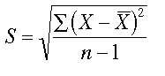
The sampling error is the standard deviation divided by the square root of the number of samples. Graph the driscriminator on the x axis and the average counts on the y axis as an xy (scatter). Put in error bars using the standard deviation. For a sample graph for setting discriminators see figure 2.

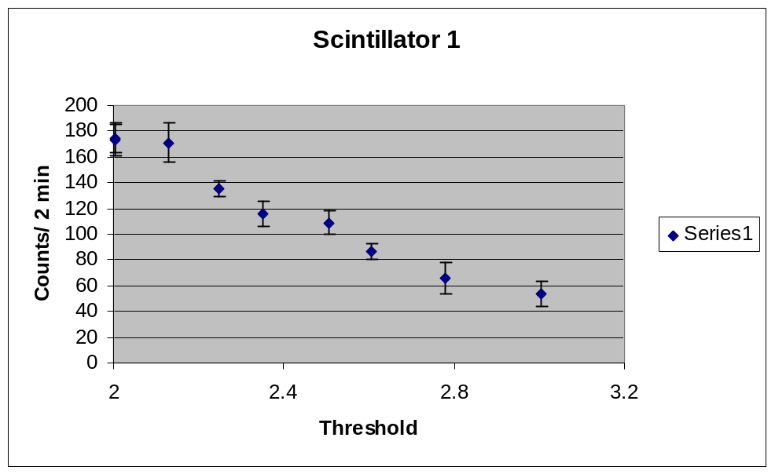
Figure 2

Note: In figure two there are y-error bars and the plateau is visible between a threshold of 2.4-2.5 volts.

Expected Rate of Accidental Counts:

Use the formula 2τN_{A}N_{B} to find out the rate that an accidental count might occur during the experiment where τ is the gate width, N_{A} is the single counts on the first scintillator and N_{B} is the single counts on the second scintillator. Watch the units, and make sure they are all the same. The answer’s units will be in counts/time used. This can be compared to the coincidences recorded on A and B and the percent error can then be found.

Conclusion:

A plateau graph should show where the best place to set the discriminator is. After this is found the scintillators can be set at the correct settings and the muon lifetime experiment can be continued.

