Muon Lifetime Report
Melanie Silver

The Muon Lifetime Experiment is classic. We know, from the Particle Data book, that the average muon lifetime is 2.19703±0.00004 microseconds. We are trying to get data that shows a muon lifetime that very close to that number.
Scintillators are used to detect muons. A scintillator consists of a photo multiplier tube, a light guide, and a rectangular piece of acrylic with organic dye embedded inside. When a charged particle comes through the acrylic it reacts with the organic dye to create a small charge of light. The light is then guided to the photo multiplier tube, which amplifies the signal and then is used as an output to further sources (i.e.: discriminator and logic gates). The discriminator sorts out the incoming signals and can be set at different voltages. When it is set too high it might not let anything in, but when it is set too low it might be detecting too much noise. The logic gates determine how you collect your data, and what counts matter.
The setup that we used for the scintillators was a square, stuffed with phonebooks to allow a greater probability for the muons to decay inside. The logic that allowed the square to work was if a charged particle enters through scintillators A, then the clock tick timer starts. If the muon decays when it is inside the box, then it will decay into an electron and two neutrinos. The electron will then hit any one of the four panels, and the timer will stop. This happens many times, and from the different times that occur between the decay and the entry from scintillators A, a histogram with an exponential curve can be found that will give the average lifetime found from the data collected. Now, it isn’t this simple. There are many steps involved in getting probable data. These include choosing the right equipment to use, and picking the optimal voltage to run the PM tubes and the thresholds at.
For our experiment, we chose to use the new scintillators that we built (see report on how to build scintillators), the WALTA board, and the FPGA. We used the oscilloscope to pick a good PMT voltage. This was done by hooking up each scintillator to the oscilloscope and changing the voltage until the reading looked to be about the right height. Then we plateaued for the discriminator voltage using coincidences. We used the WALTA to get the data.

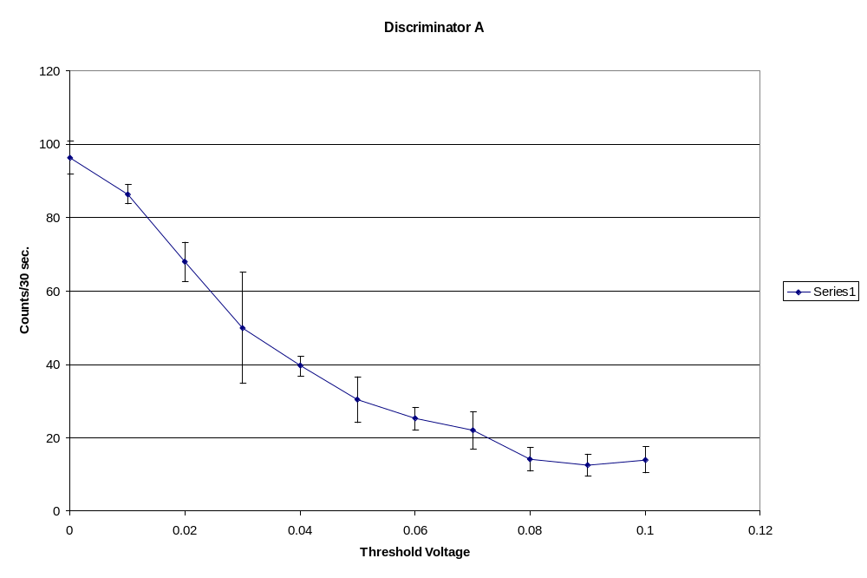

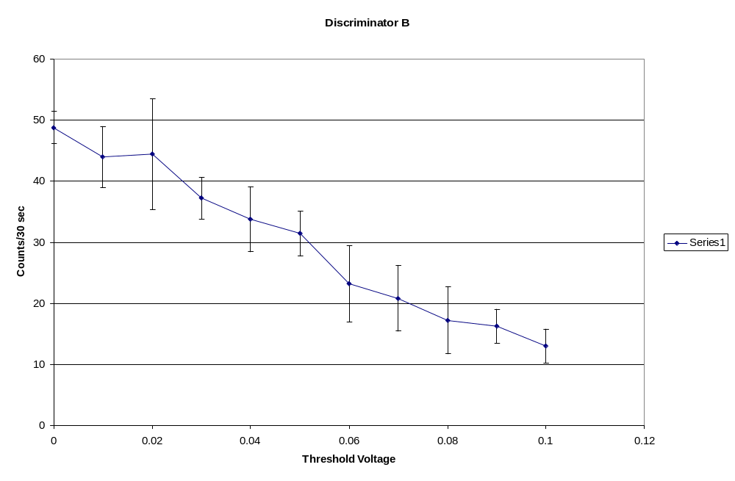

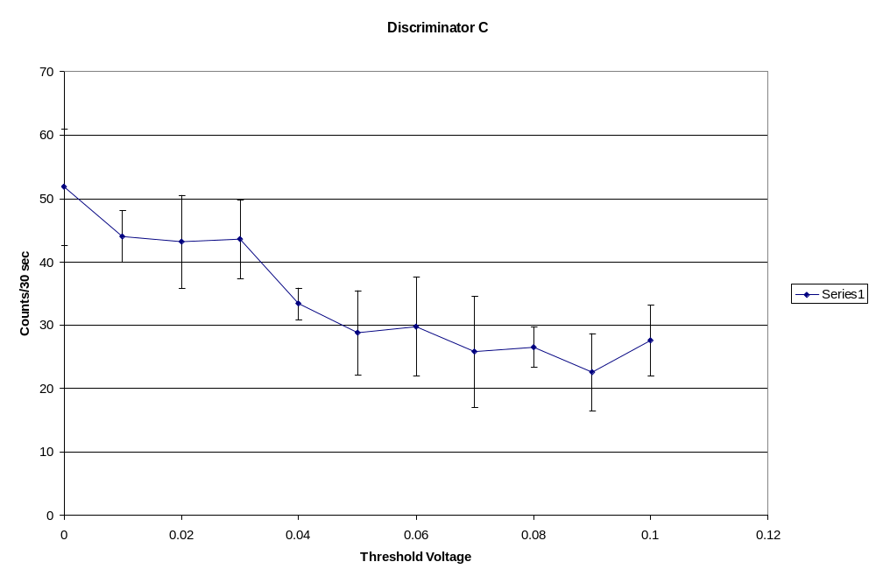

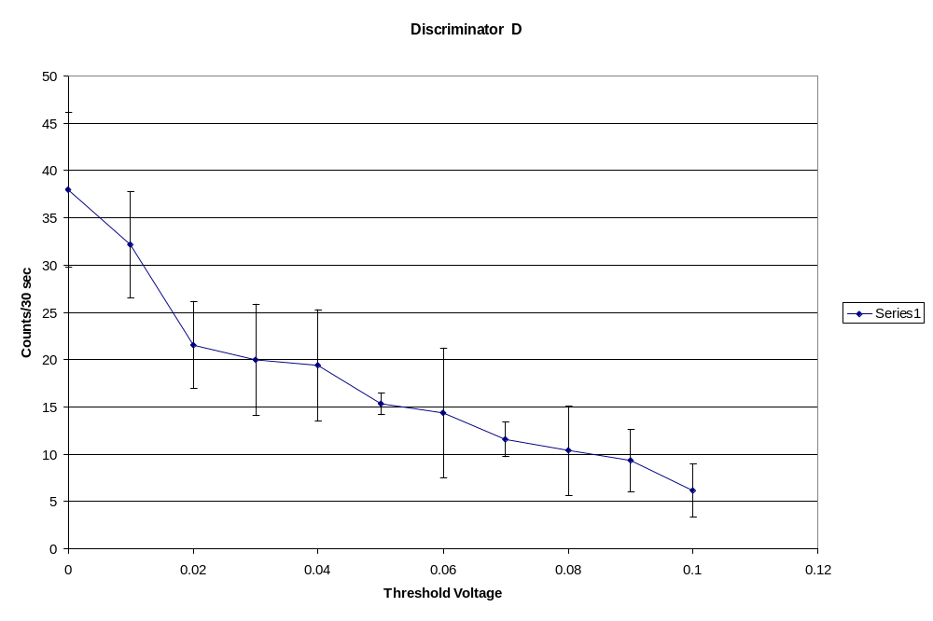

On how to plateau see the report on how to plateau scintillators. To view the data from the plateauing see the data link on plateauing. The optimal settings that we chose for the scintillators were:
A: PMT 854V Threshold 0.06v
B: PMT 851V Threshold 0.04v
C: PMT 854V Threshold 0.025v
D: PMT 854V Threshold 0.03v

Then we hooked up the equipment to run the experiment. Earlier we found out that we had to amplify the WALTA pulse in order for the FPGA to pick it up. So from the WALTA we went to an additional discriminator and level adaptor, then to the FPGA. We ran the experiment overnight for 9 hours. We put the data into excel and graphed a histogram.

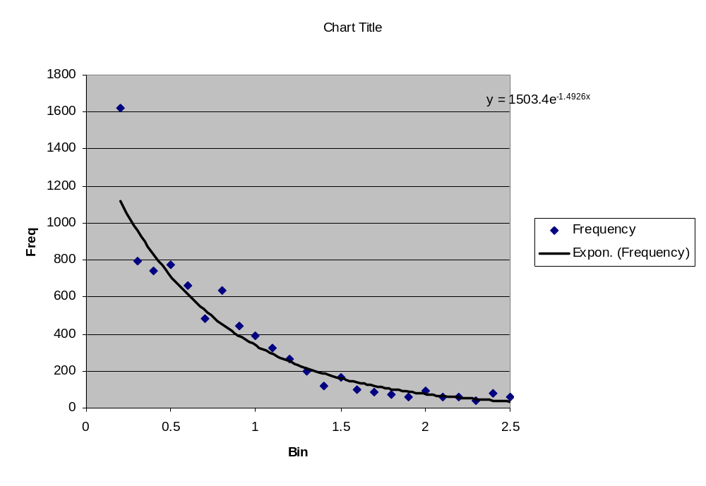
The lifetime data that the graph showed wasn’t even close to 2.2 microseconds. We took the negative inverse of the exponent in the equation to find the lifetime. Because of the discrepancy we decided to do a check of the equipment and run it again. For more detail on how to fully analyze data see the report on Analyzing Decay Time Data. Unfortunately when we checked back on the equipment we found that there was some faulty wiring, so we were getting frivolous data. The experiment will continue over the coming school year.

