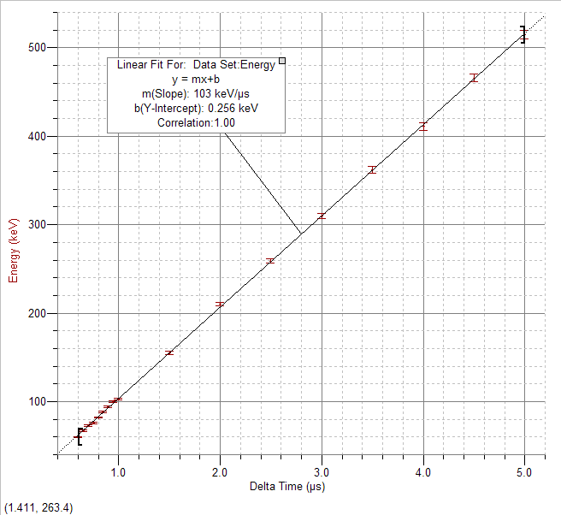
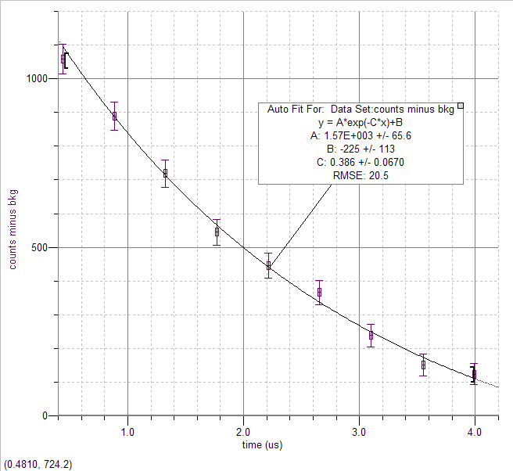
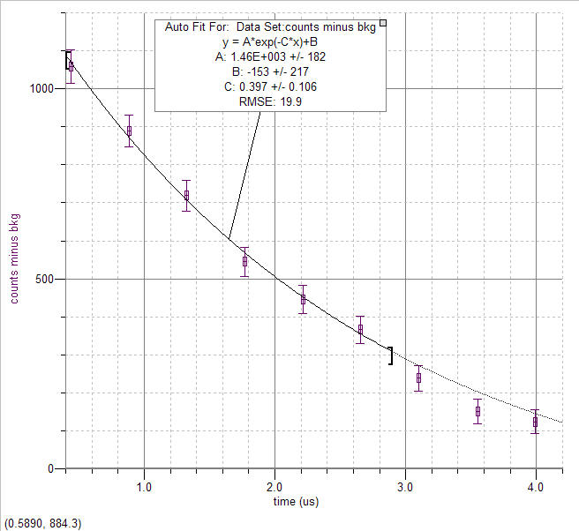

Here we don’t fit to the high region where the signal is not as high above the background.
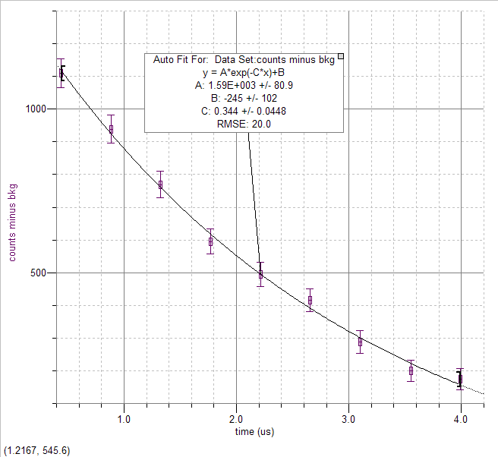
This graph is with a bkg subtraction of 400 instead of the estimated 450. There is a difference.
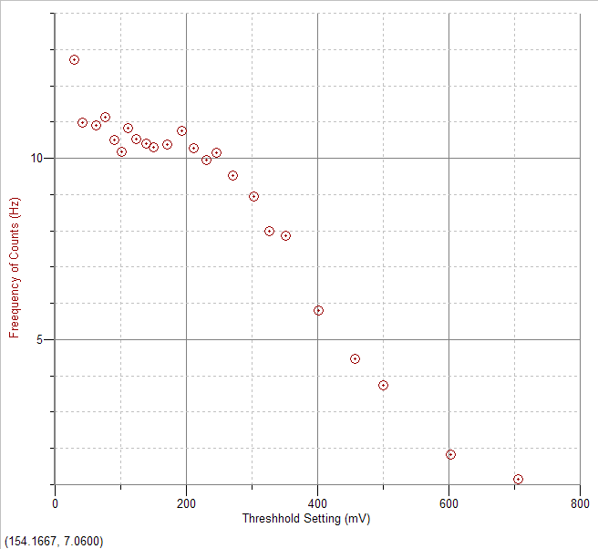
Coincidence graph of scintillators A and B. Threshhold A is fixed at 67.749 mV and Threshhold B is varied.
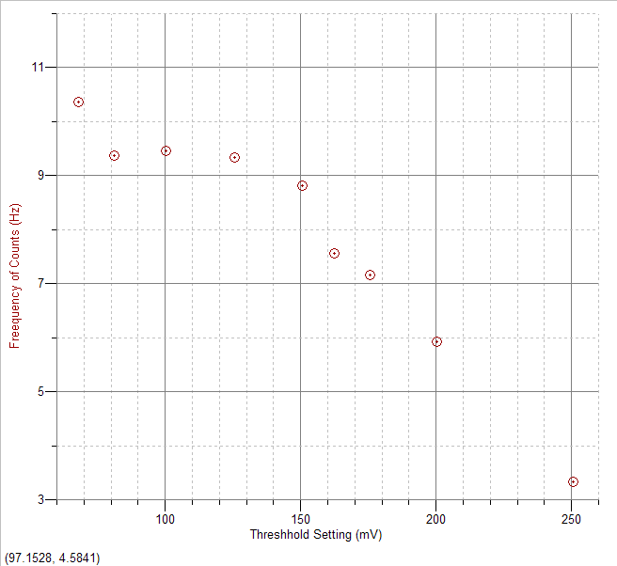
coincidence of A and B; threshold B fixed at __________; threshold A is varied
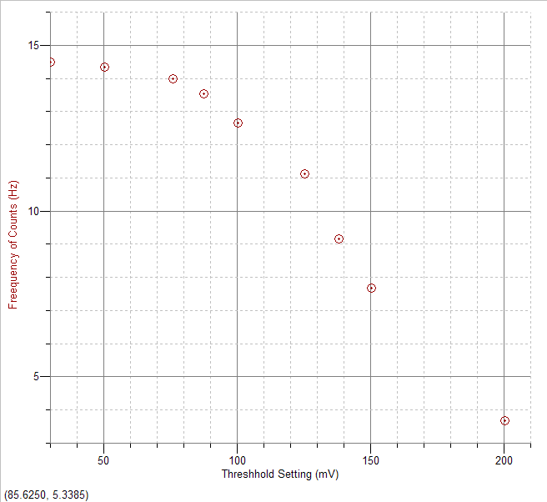
scintillators B and C: B fixed at __________; C varied

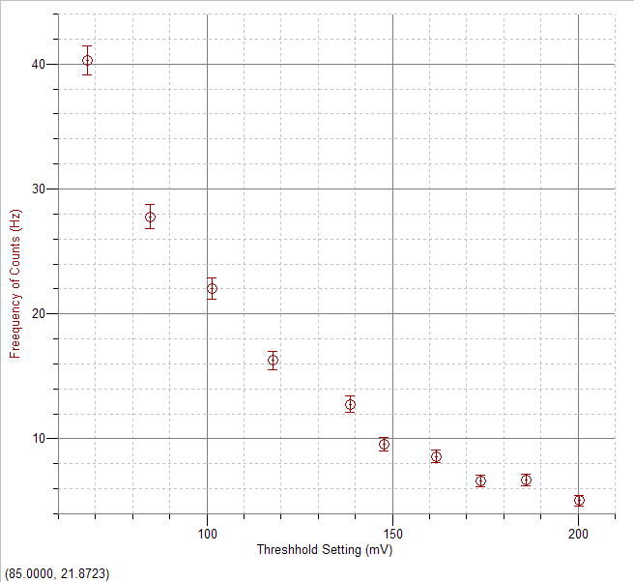

Scintillator A
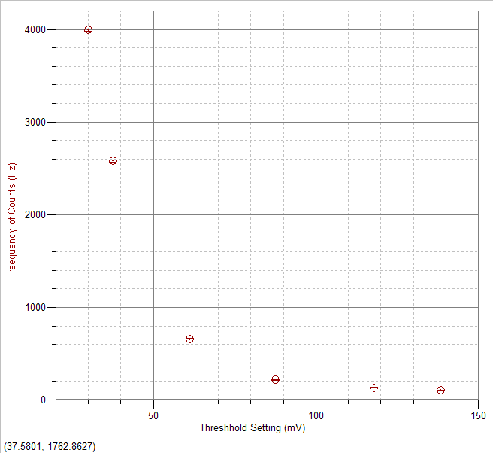

Scintillator B
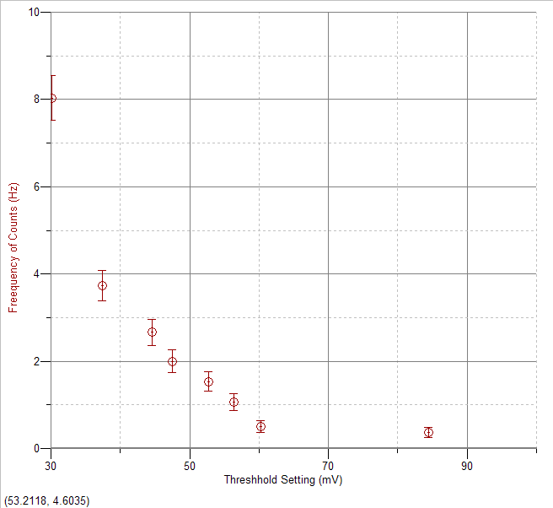

Scintillator C
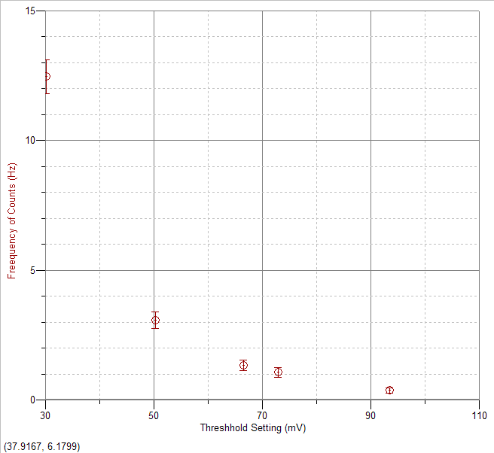

Scintillator D
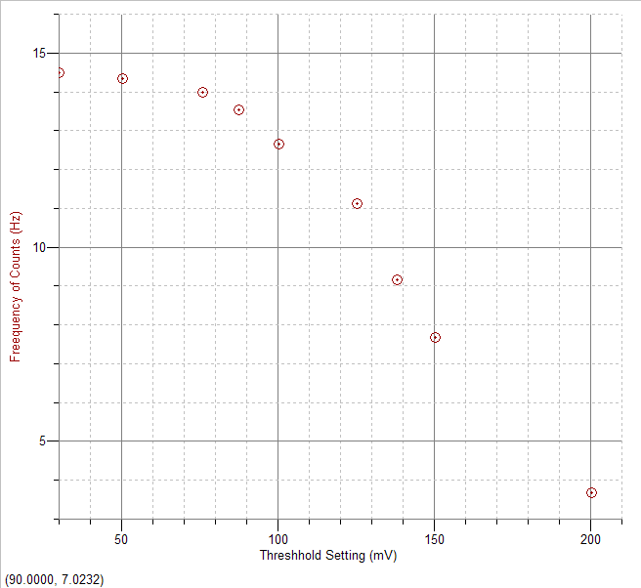

Adjusting scintillator C discriminator threshold keeping B fixed
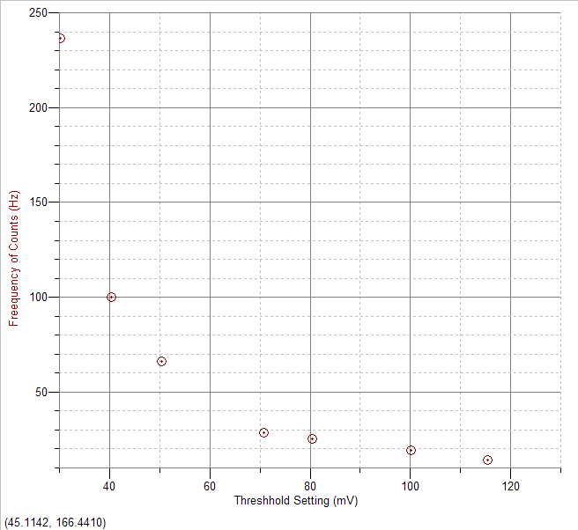
Scintillator C, singles

