Cavendish Experiment

Gabriel Shields-Estrada
Tiffany Meshkat

July 23, 2004

Abstract
The Cavendish Experiment is designed to discover the value of the gravitational constant. It involves a suspended balance with two 15 gm lead weights on each side. A mirror in the middle of the balance reflects a laser on to the wall. The balance is subjected to two 1 kg lead balls which moves the position of the balance, consequently moving the reflected laser light on the wall. This experiment was originally performed by Henry Cavendish in the 18th century and had alarmingly accurate results.

Introduction
In the 17th century Newton discovered and stated the laws that explain the everyday, forces that act on matter. His principal laws, (1) an object in rest stays in rest unless acted upon by an outside force, (2) the velocity of an object that is acted upon by an outside force changes, and (3) if an object is acted upon by an outside force it will push back with an equal and opposite force, make it simple to calculate how much force is acting upon an object, in everyday conditions. Many of his most important and well-known laws are dependent on gravity. However, without knowing the value of the gravitational constant (G), in the equation
F= G M1 M2
r^2
one cannot determine the force of an object upon another object.
When Henry Cavendish began his quest to determine the value of G, both the value of the mass of the Earth and the value of G were unknown. Eventually his discovery of the gravitational constant led to the calculation of the mass of the earth. As is always the case in the physics world, the story of his experiment has, over time, become more myth than fact. Henry Cavendish was known as an antisocial person. When the issue of determining the gravitational constant surfaced, Cavendish designed and executed his now famous experiment. His experiment was performed in the basement of his castle, where he suspended a balance holding two large weights. Since precise lasers were not available at the time, Cavendish ingeniously used a focused beam of light from a lantern. Although his experiment appears to be extremely imprecise, the results were extremely, even amazingly, accurate.
Procedure
In order to recreate this experiment and to determine the value of G, we used a similar setup, but made more precise measurements. As demonstrated in Figure A, a balance with 15 gm lead weights is suspended by a gold-plated Tungsten wire of diameter 25 microns. A second balance holding two 1 kg lead weights is then rotated so its gravitational affects upon the smaller lead weights rotate the balance. A mirror attached to the center of the balance reflects a laser light onto a wall, 1.75 meters away, helps to illustrate this attraction in a more visible manner. Using the distance the light has traveled, the angle the balance has rotated, the mass of the lead balls, the distance by which the masses are separated and the distance that they have rotated, one can determine the gravitational constant (G).
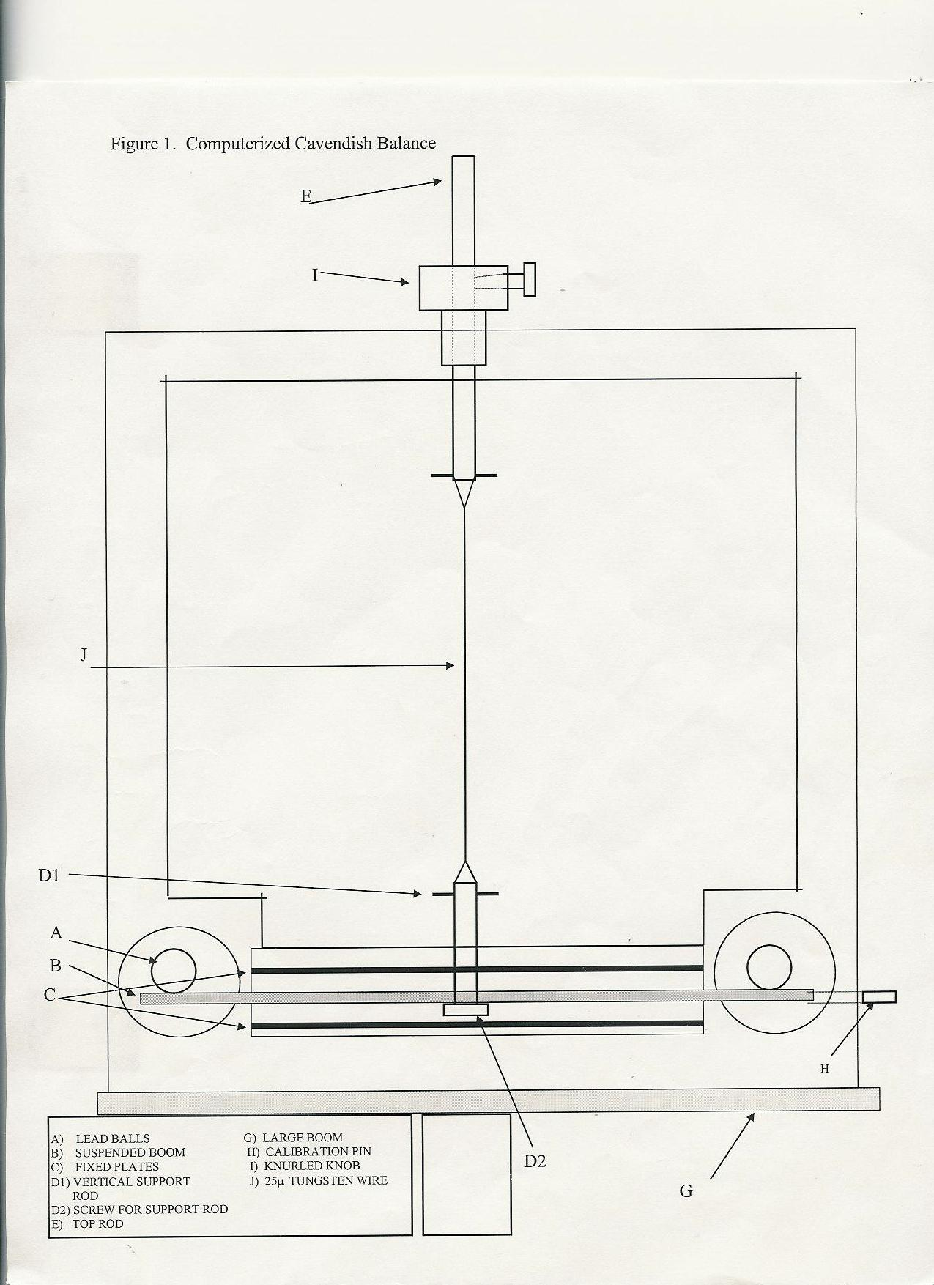

Problems
The two most difficult components of the experiment were tying the gold-plated tungsten wire to the top of the set up and the balance it suspended, and waiting for an extended period of time to see the rotation in the balance. Tying the 25 micron diameter tungsten wire was extremely difficult because, in order to minimize the stress on the wire and distribute the force equally, it was required to tie the wire in the intricate fashion demonstrated in Figure B. The second challenge of waiting for an extended period of time was accomplished more easily but required great patience. Our initial measurements, recorded after letting the larger weights act upon the smaller weights for one hour, clearly illustrated the expected initial fluctuation. Due to this fluctuation, a 24-hour period was required before the balance had settled into its final position, equilibrium between the force of the large weights was achieved and the force of the wire twisting back against the force of the weights.
The most prominent problem was the major time constraint. Although the experiment itself does not take more than a few days, more time would have been beneficial because it would have allowed for more time more precise measurements. Additionally, more time would have allowed for numerous trials which would reduce the percent error.

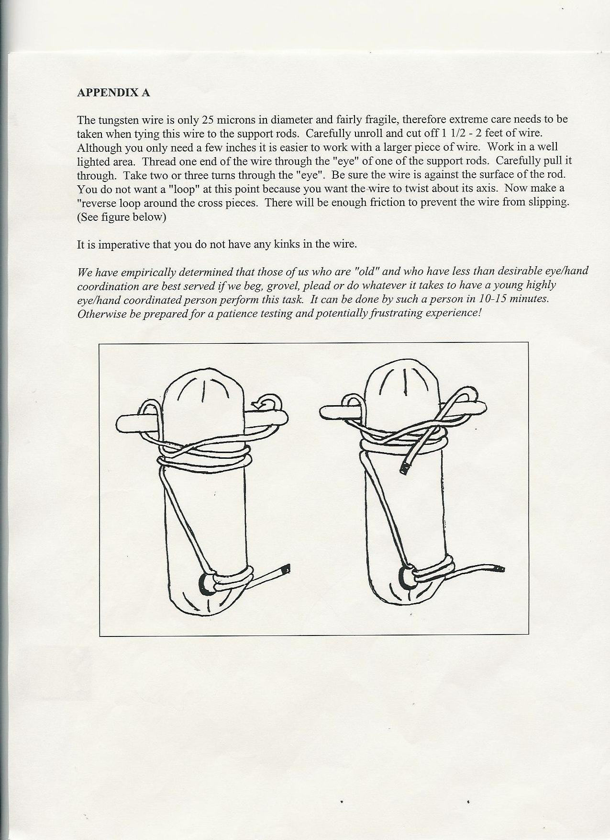Results
The variables were determined by many different methods. The value of M1 and m2 were determined by using a scale. The distance between the two weights was measured to be 2 cm. The distance from the axis of rotation to the weights on the balance was measured to be 6.55 cm. These variables are put together to determine the gravitational torque, however G is still unknown. The angle of rotation was found by using the distance to the wall (1.75 meters) and the length the laser moved on the wall (1 mm). By using the Pythagorean Theorem, the angle of rotation was determined to be 5.71 x 10^-4 radians. With the given torsion constant in the gold-plated Tungsten wire (1.41 x 10^-6 Nm) the torque in the wire can be determined. In equilibrium, the two torques should be equal. By making the equations equal, the gravitational constant (G) can easily be found. With the imputed data, the gravitational constant was found to be 6.57 x 10^-11 Nm²/kg².
Analysis
The results of this experiment demonstrate in a clear fashion that all matter attracts all other matter at a constant rate. Although our results were off by one tenth of a Newton, we calculated 6.57 x 10^-11 Nm²/kg² and the actual amount, as proved by scientists (6.67 x 10^-11) this miniscule differential is not problematic. In fact the results we received were extremely satisfactory. Admittedly, this accuracy is due partly to luck and partly to careful measurement. Throughout the experiment, much of the measurement error was accounted for by other measurement error. In other words, if one measurement was plus or minus 5% and another was also plus of minus 5%, the two canceled each other. Luckily, this fluctuation gave us an extremely accurate answer. Furthermore, our results demonstrate the universal gravitational constant is indeed 6.67 x 10^-11. The fact that the gravitational constant is not fluctuating greatly has a great effect on the entire universe. If the constant were to change for any reason, life in this universe as we know it would change drastically.
Conclusion
Although the project has been completed, that does not necessarily mean that we can answer all of the more pertinent questions relating to the universal gravitational constant. In fact, there are still many related questions that need to be answered, for example, “why is the gravitational constant always constant?” and “does the gravitational constant stay constant throughout the universe, even black holes?” There are many questions in science that have yet to be answered, but performing experiments, like the Cavendish experiment, help the human race understand the fundamental laws which govern the universe.

