Track Reconstruction Documentation December 10, 2006

In particular, this document provides an analysis of so-called “outside in” (Tim Nelson’s AxialBarrelTracker) track reconstruction for Monte Carlo collider simulations. That is, algorithms designed to use only particle hit information from the central tracking layers to reconstruct tracks that originate outside the VXD layers (algorithms that rely on seed tracks from the VXD are typically inefficient for tracks originating beyond the second layer of the VXD at r ~ 2cm)

In order to examine the effectiveness of these algorithms, a list of events with usable shapes must be defined, known as “Jet Accept Test”. These restrictions are:

Cosine of the Thrust Angle < 0.5
Thrust Value > 0.94

Thus producing set of MC events from which to draw on. From the track banks of these events, all particles that originate within a radius of 20 mm of the origin are removed from the particle lists, and all of their hits are removed from the hit list – the process performed by the “cheater”. Of the remaining tracks, we define a set of “findable” particles that meet the conditions:

Final State or Intermediate State with R Origin < 400mm and Pathlength > 500mm
Transverse Momentum > 0.75GeV
Carry a charge
Cosine Theta < 0.8
Not backscatter off of the Calorimeter

Using the afore-mentioned conditions, analysis code and the AxialBarrelTracker algorithm were run on various event files.

The following results were obtained with pythiaZPolebbbar-0-1000_SLIC_v1r9p3_sidaug05.slcio, which was generated without the effects of beamstrahlung or brehmstrahlung
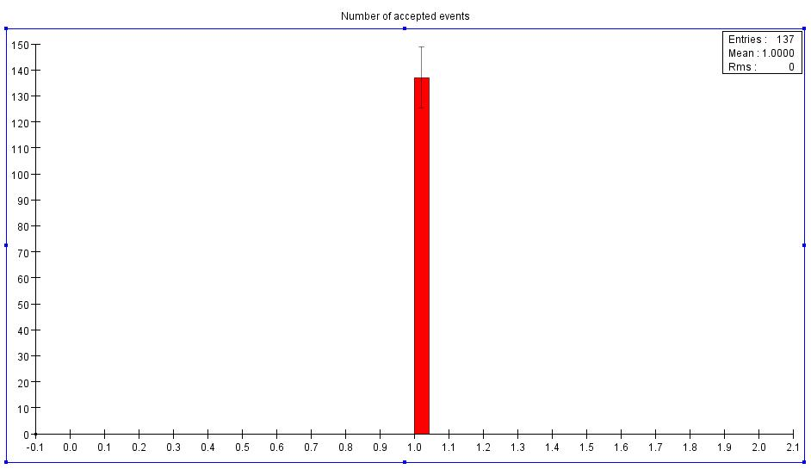

Figure 1: Events passing JA (Jet Accept) cuts.

Here 137 events pass the Jet Accept Test parameters out of 1000, or 13.7%.

Next, we examine the particle banks for each passed event. In this case “FsList” is the list of MC Particles that pass the “findable track” requirements, and the “Total List” contains all MC Particles regardless of their nature. The ratio of accepted to total is also histogramed. Keep in mind that each entry is per event.

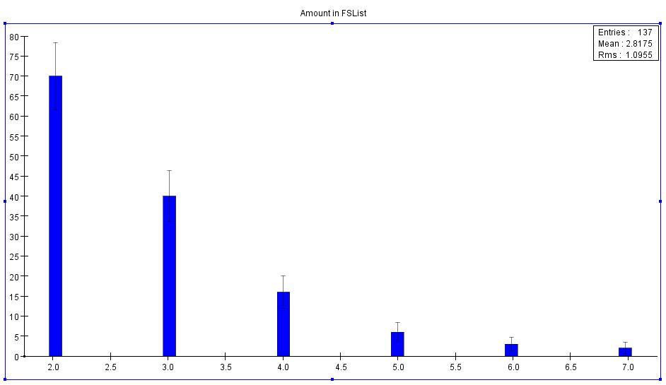

Figure 2: Number of “findable” particles per event, after prompt tracks have been removed by the cheater.

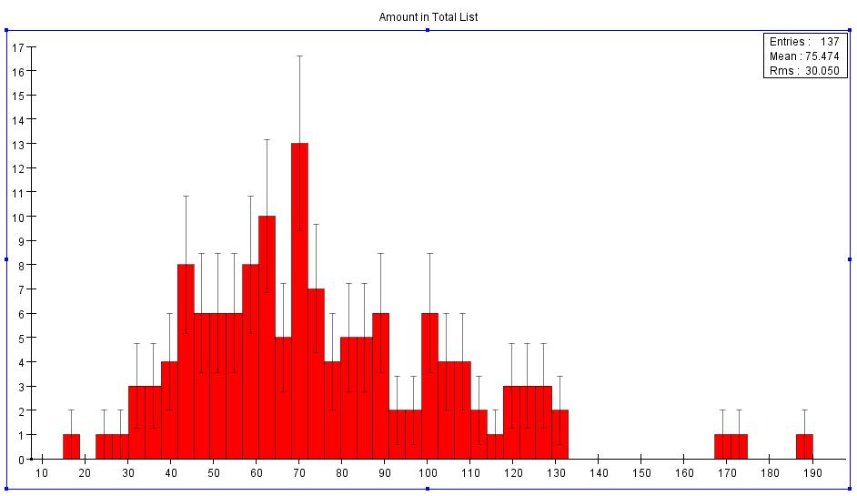

Figure 3: Total number of particles per event for events passing JATEST, with prompt tracks excluded by the “cheater”.

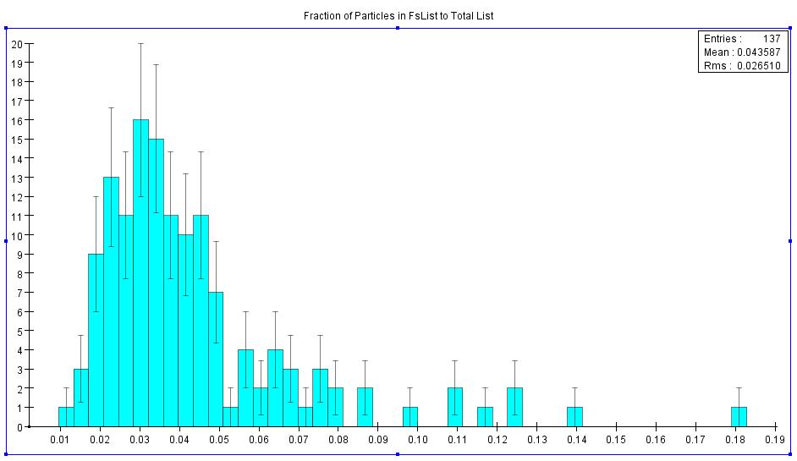
Figure 4: Fraction of total particles (after the cheater is run) that are “findable”.
As one can see, there is a distribution of percentages with a mean of around 3%. This implies most particles originating from the event are not “findable”. These are probably very low-momentum tracks from backgrounds, although we haven’t checked this.

Next is an examination of the efficiency and purity for finding MC particles. Here each MC Particle is looked at, then the entire list of reconstructed tracks is run through. If the particle is found and reconstructed with a purity of greater than 75% (three or more out of 4 or four or more out of 5 hits on the reconstructed track are from the same MC Particle) then it is plotted in “Found MC Particles with Hits” along with the corresponding number of hits that the track had made in the detector (note that the AxialBarrelTracker algorithm requires that any found track have at least four hits). If the purity is less than 75% but has a predominant number of hits from a particular MC particle, the MC Particle is labeled as “found”, but the poor purity is indicated by plotting it with 0 hits in the following histrograms. Also, the corresponit is defined as a “fake track” and plotted with 0 hits (this is just used as a counter and has nothing to do with the actual number of hits for the fake track). If the particle is not associated in majority to any track then it is plotted with 0 hits in the “Missed MC Particles” histogram. The total number or findable MC particles, therefore, is just the addition of these two entry numbers, or 380 Total Particles. Out of these, 115 Are found with 5 hits (30%), 88 with 4hits (23%), 20 with bad purity (6.5%), and 155 were missed (40.5%).

As it stands there are numerous occasions where an MC particle is found more than once. For the plots and efficiency estimates above, the information for the first time it was found is used, then the particle is removed from the bank. However, a record is kept of how many times a given track is found with four or more hits (see fig. 7). There is no purity cut on these multiple-track findings.

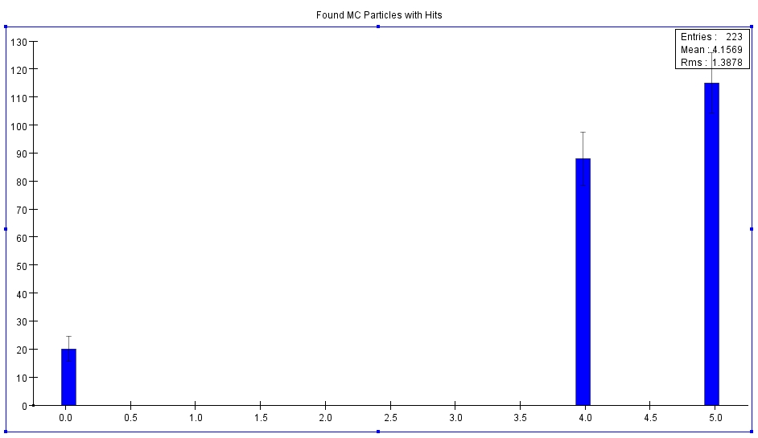

Figure 5: Representation of the number of hits for found MC particles (they can only be found once, and some MC particles are not found at all, or “missed”), where “0” hits represents tracks that were found with purity under 75%. For missed MC particles see figure 6.

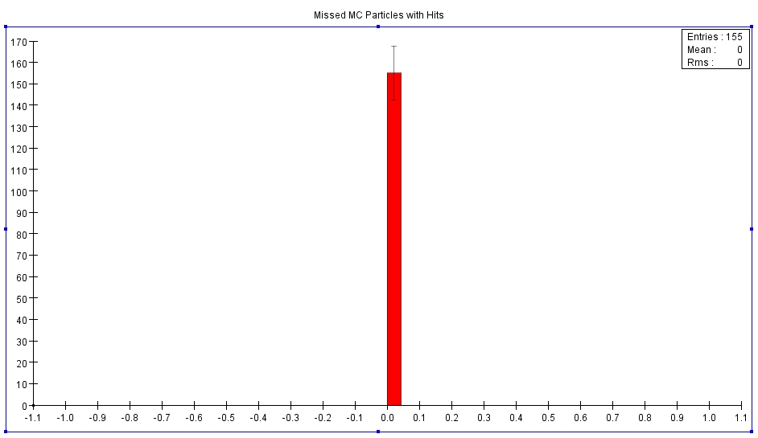

Figure 6: Number of MC tracks that were not found by the tracker at all.

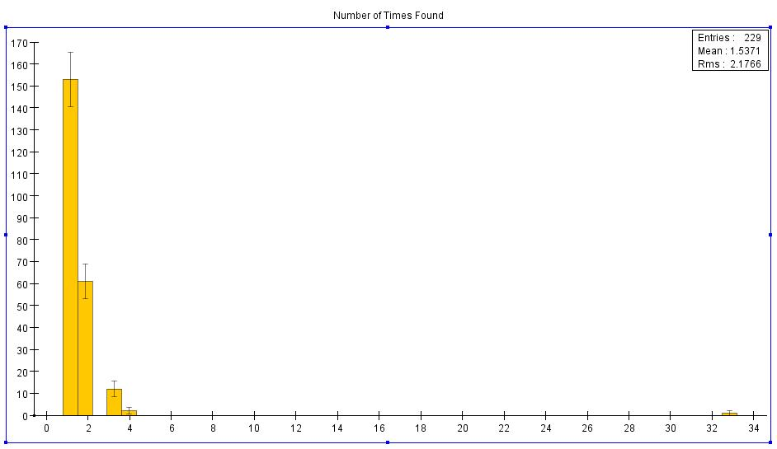

Figure 7: Number of times a findable MC particle is found, where most are found once or twice. A small percentage is found several times.

One interesting result is that almost every low purity “fake track” is found with only four hits. This is illustrated with figure 8, which includes majority MC particle tracks with low purity (the entries at 0 in Figure 5) as well as low purity tracks with no MC particle associated with them. As one can see, there are a lot more “fake tracks” containing hits with all different MC particles, than those with a majority of one particle (more than 10:1).

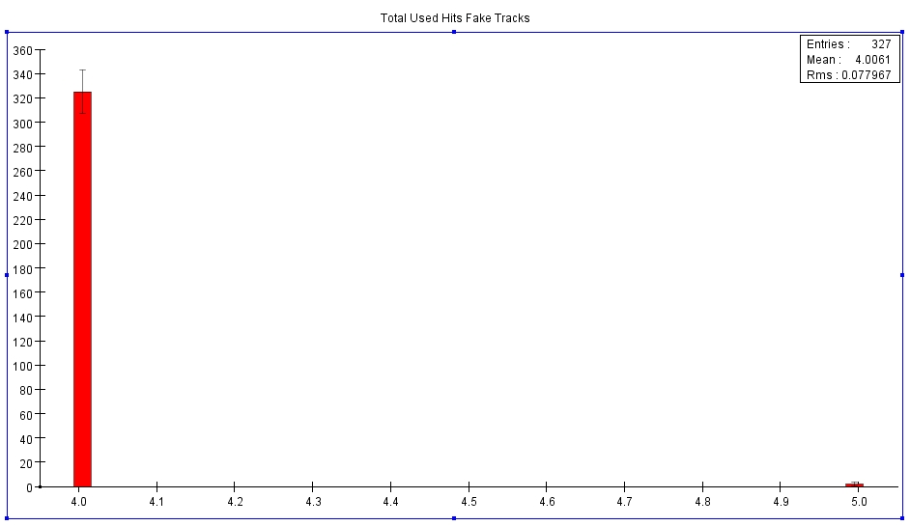

Figure 8: Plot of the number of hits on reconstructed tracks assigned to a MC Particle with low purity, or not assigned to a MC Particle at all.

Where 326/327 fake tracks have 4 hits! This illustrates that if we require all 5 layers of the detector to be hit, we may obtain a very pure sample of reconstructed tracks (high “track purity”). On the downside, however, if we require all 5 layers we would lose the found MC particle tracks with 4 hit layers, making the overall efficiency about 30%. On the other hand, if found tracks with four hits are allowed, the efficiency increases to 53%, but the track purity drops to only 38%.

On examination, the Radius of Origin (x-y plane only) of found, fake and missed tracks yields

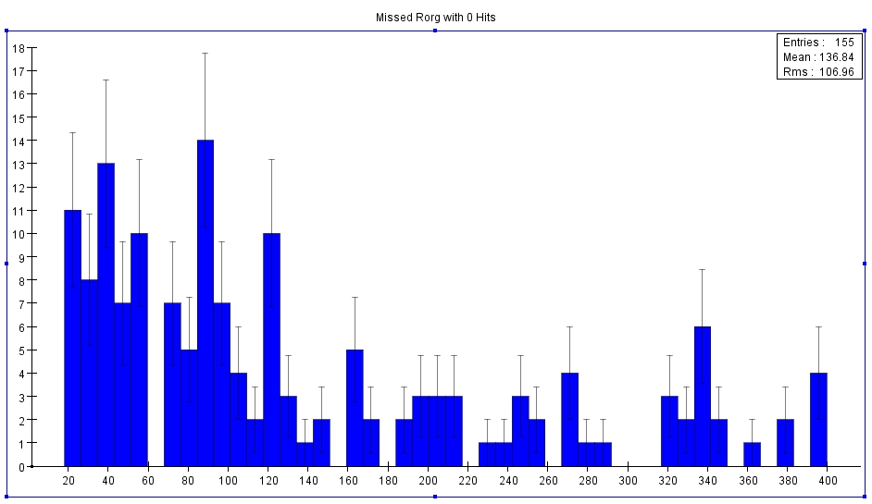

Figure 9: Radius of Origin for Missed MC Particles

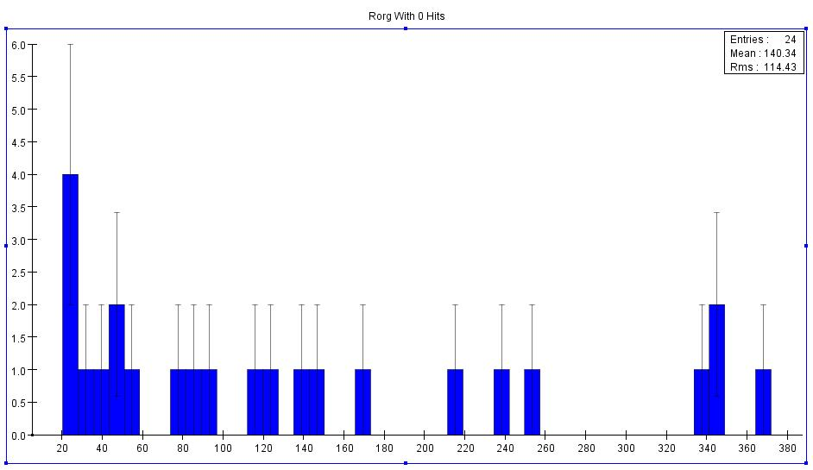

Figure 10: Radius of Origin for MC particles reconstructed with low purity.

Where the two plots above are made for the missed particles and ones with low hit purity. In other words, these are the “Problematic Particle Plots”.

The following two plots are for MC particles found with acceptable hit purity.

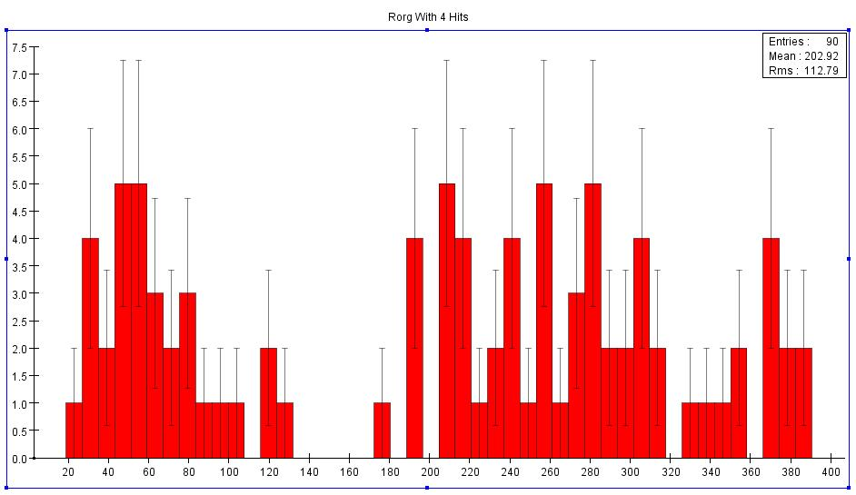

Figure 11: Radius of Origin for found particles with 4 hits

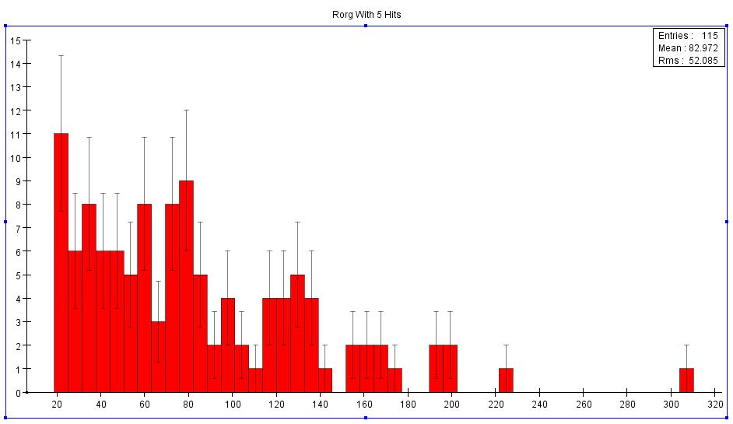
Figure 12: Radius of Origin for found tracks with 5 hits

As expected the pure 5hit reconstructed tracks have majority Rorg at the lower end of the spectrum. However, the remaining three seem to have no correlation. Thus, more probing is required into the reason for fake and missed tracks.

The next step in this ongoing process will be to further explore the reasons for having so many four hit tracks as well as explanations as to why so many MC particles meeting the findable criteria are being missed.

